**Comparing and contrasting adoption of technologies used overseas to New Zealand for managing variability on farm.**

**Kellogg Report**

**Oliver Knowles**





# Forward

This report was required as participation and completion for the Kellogg Rural Leadership Programme. It was an honour to be selected for this programme, and allowed me to reflect on the sector of the industry I am currently working in, which leverages my passions of knowledge transfer, technology and farming.

The Kellogg programme has provided time to reflect on my current position of employment and personal life. This reflection has given me the renewed direction and drive I needed for my career in the primary industries of New Zealand.

I could not advocate more highly for others in the rural sector to participate in the Kellogg programme as the skills learnt, people met and experience gained appears to provide a great foundation for becoming a leader who inspires and encourages.

# Acknowledgments

I would like to thank Ballance Agri-Nutrients for the financial support of putting me through the Kellogg Rural Leadership Programme. I would also like to extend my gratitude to Yara International for providing insight into the N-Sensor, for use as a case study in this report.

I would also like to extend my gratitude to the strategic partners of the Kellogg Rural Leadership Program for their ongoing commitment to developing the future leaders of New Zealand’s primary industries. The strategic partners:

* AGMARDT
* Beef + Lamb New Zealand
* DairyNZ
* FMG Advice and Insurance

An extended thank you also needs to go out to my friends and fellow Kelloggers, who provided support while I completed this project. With a special thank you to Charlie Harrison for providing the drive, to striving for greater opportunities.

Finally, thanks also needs to be given to the Kellogg Rural Leadership Program staff, Desley Tucker, Anne Hindson and Dr. Patrick Aldwell who put such a great effort into the program which quite often extends into their personal time.

# Authors Contact Details

Oliver Knowles

[ollieknowles@hotmail.co.uk](mailto:ollieknowles@hotmail.co.uk)

0277020301

# Table of Contents

Forward i

Acknowledgments i

Authors Contact Details i

Table of Contents ii

Executive summary 1

1. Literature Review 3

1.1 Introduction 3

1.2 Precision Farming 3

1.2.1 History 3

1.2.2 Precision farming in New Zealand – past and present 4

1.3 Extension Strategies for Adoption 6

1.3.1 Defining extension – the early days 6

1.3.2 Current state – extension strategies 12

1.4 Extension used in farming 13

1.4.1 Linear ‘top-down’ transfer of technology 14

1.4.2 Participatory ‘bottom-up’ approaches 14

1.4.3 One-to-one Advice 15

1.4.4 Structured education and training 16

1.4.5 The extension spectrum 17

1.4.6 Technologies and other techniques used to further develop extension approaches 17

1.5 Conclusion 18

2. Introduction 20

2.1 N-Sensor® 20

2.1.1 Increase nitrogen efficiency 20

2.1.2 Benefits of using the N-Sensor 20

2.2 GPS - **Error! Bookmark not defined.**

3. Method 25

4. Findings and Discussion 26

4.1 N-Sensor® 26

4.2 GPS - autosteer 27

4.3 Comparing adoption of technology between New Zealand and overseas 28

5. Conclusion 29

6. Recommendations 30

References 31

# Executive summary

The growing trend in precision farming (PF) comprises technologies that combine sensors, information systems, enhanced machinery, and informed management to optimise production by accounting for variability and uncertainties within agricultural systems. Adapting production inputs site-specifically within paddocks and individually for each animal enabling better use of resources to maintain and improve the quality of the environment while improving the sustainability of food supply and security. Precision farming is now providing a means to monitor the food production chain and manage both the quality and quantity of agricultural produce. A key area of growth in terms of scientific development and validation is in the area of sensors and precision application to manage the increased level of information. Although the benefits from PF appear to be endless, in New Zealand there is a lack of understanding and insight into adoption of precision farming technologies.

The purpose of this report is to provide insight into extension strategies for PF technology adoption to improve New Zealand’s ability to aid the adoption process through a more considered extension approach including details of:

1. Trends in precision farming overseas and in New Zealand
2. Diffusion and adoption overview
3. Currently recognised rural extension strategies
4. Overview of two PF technologies available overseas and in New Zealand.

Data accessible online and through Ballance Agri-Nutrients network identified two technologies, the N-Sensor® and global position systems (GPS) as case studies. The information available on these technologies was used to identify how they have been adopted overseas compared to New Zealand, and if any extension approaches were developed to aid their adoption. The extension approaches for each of the technologies have been compared and contrasted to industry recognised extension approaches, to provide improvements for future PF technologies released to the rural sector.

Although a comparison was made between countries, regarding adoption of the case study technologies there was little insight gained due to the lack of data available for a robust comparison. Further to this, the relevance of a country when reviewing extension approaches was found to have little to no influence on the adoption rate. Beyond this exception, there were some similarities and differences between how the case study technologies were released to market and aided or in the instance of the case studies, were unsupported by deliberated extension approaches, but the major consistencies were:

1. Lack of deliberate extension strategy.
2. Improvised linear ‘top-down’ transfer of technology.
3. Dependant on highly technologically perceptive farmers.
4. Technology developed by researches or in another field, which “found” a solution in the agricultural sector.
5. Hugely dependant on external drivers to get adoption over the ‘chasm’ – greater than 15% adoption in the market place.
6. Lack of consolidated data to assess rates of adoption and impacts of extension approaches.

As the adoption of PF technologies in New Zealand is perceived to accelerate with the expectation that the majority of innovations for PF will become industry standard. This report recommends that through utilising current and future case studies and leveraging the knowledge and skills of extension process and practices greater adoption of PF innovations can be achieved by:

1. Greater attention and emphasis should be placed on developing extension approaches through the development of an innovation.
2. Identifying target markets and involving the potential adopters through the development of the innovation is reported to have a great improve on rate and success of adoption.
3. Data of technology adoption should be captured on a national level to provide insight into rates of adoption and technology transfer within the agricultural industry.
4. Identified through the literature review, the lack of knowledge around the level of education attained by New Zealand farmers was revealed. This should be reviewed as it may influence their ability to critically analyse the farm system and be able to identify issues and work through solutions.
5. As this is a review with case studies applied to a theoretical construct, further research should be conducted into understanding the potential of planned extension strategies with precision farming innovations.

Precision farming presents a great opportunity in managing variability on farm to an every declining scale. There are currently innovations that are well down the track of the innovation categories while others have yet to become commercially available. Although precision farming has been around for a number of decades, it is still in its infancy here is New Zealand but this will be overcome by time. With a greater focus on extension practices and processes in the rural sector, the impact of PF on the wider industry and society as a whole will be realised.

# Literature Review

## 1.1 Introduction

Managing variability on farm has been at the forefront of farmers’ minds for decades. Since the 1980s, the term precision farming (PF) was coined (Corwin & Lesch, 2003) to summarise the evolving trend in the rural sector. The trend of PF was developing to enable the management of areas, people, animals and assets to a continuously declining scale and extent and increasing intensity and magnitude. Although it may appear that solving this problem is straightforward, a plethora of technologies has been developed in the rural sector in the aim of providing solutions (Brisco, Brown, Hirose, McNairn, & Staenz, 2014; Corwin & Lesch, 2003; Griffin & Lowenberg-DeBoer, 2005; Pedersen, Fountas, Blackmore, Gylling, & Pedersen, 2004). More often than not, these technologies stall in their adoption in the market place or are completely rejected and are superseded by a ‘bigger and better’ alternative (Black, 2000). Yule and Grafton (2016) reported adoption of PF is not well documented in New Zealand, as it is hard to obtain adoption figures of component technologies.

Leveraging the reviews such as Rogers (1983) on diffusion of innovations, as a foundation for understanding the process of adoption, to gain insights to how PF technologies are adopted and their rate of adoption improved. More recent work carried out by Black (2000) and demonstrated as a frame work by the Australasian Pacific Extension Network (APEN) (2016) have built on Rogers (1983) review and reports have since demonstrated the process in the rural sector where innovations have been taken up or developed by a market.

The objective of this review is to examine PF and the adoption strategies available for extension of technologies used to manage variability on farm and therefore evaluate:

1. the extent of PF in New Zealand,
2. what extension strategies exist to aid adoption,
3. extension strategies used in the rural sector.

This will be evaluated by the current state of knowledge and understanding of PF in New Zealand, developed extension strategies, along with the effect of these strategies to aid adoption in the farming context.

## Precision Farming

### History

Managing variability on farm has been a focus for over a decade, nationally and internationally since the 1980s, where it has now been termed as precision farming (PF). Corwin and Lesch (2003) stated the term precision farming was first conceived in the mid 1980’s and that the technological pieces needed to bring it into its own fell into place in the mid-1990s with the advancement of global positioning systems (GPS) and geographical information systems (GIS). The area being managed has decreased over time starting out as comparing blocks then to paddocks followed by within paddocks and more recently to comparing areas just over 2 cm2. PF has primarily been used in arable farming and is typically the sector to first adopt precision technology (Pedersen, Fountas, Blackmore, Gylling, & Pedersen, 2004). However, over time, other farming sectors adopt the technology and this typically occurs with the technology progressing with improvements, standardisation, integration and a reduction in costs (Pedersen, Fountas, Blackmore, Gylling, & Pedersen, 2004).

Internationally, drivers behind the use of PF technologies have focused on food security, environmental impact and risk, human and animal welfare, optimising production and quality and improving economic return (Barrett, 2002; Griffin & Lowenberg-DeBoer, 2005). However, where farmers typically focus their attention is on improving yields and increasing efficiencies (Pedersen, Fountas, Blackmore, Gylling, & Pedersen, 2004). This is normally managed in a 4-point cycle where a crop or animal is growing. The first steps in the cycle typically involve (1) measuring an aspect of what they are farming, (2) processing and analysing the information, (3) diagnosing the issue or understanding the variance and (4) carrying out an action based off the diagnosis, and then returning to the first step. Therefore, a key aspect to this cycle is being able to measure aspects of the farming system and once this has been created it typically drives a want for more frequent and at a finer resolution. Areas where more data is being captured from is through the increased use of sensors that can measure differences beyond the ability of the human eye. Sensors, which are becoming more frequently used on farm, can measure soil and plant water content, nutrient concentrations in plants and plant growth. The sensors are able to carry these activities out in various modes of action whether it is by electrical conductance or resistance, colour reflectance or various frequency waves ranging from radio to ultraviolet. The sensors can range from the human eye to earth observation satellites. The most common sensor used on farm would be through visual observation, noted via GPS, and recorded in a GIS platform (Brisco, Brown, Hirose, McNairn, & Staenz, 2014).

The resurgence of PF in the last few years can also be attributed to the commercial sector where the technology offered was not and in most situations still is not, well adapted to the agricultural sector. The systems were not well adapted to the needs of the farmer and have not been easily integrated into an effective solution, which has left room for a proliferation of offerings in the market. This has seen farmers turning to research institutes to provide objective views and comparisons on the merit of the technologies. This then lead to an increase in scientific knowledge, which is finally disseminating out to farmers (Brisco, Brown, Hirose, McNairn, & Staenz, 2014).

The latest drive in PF is developing systems, which can manage the large parcels of data captured, followed by processing to enable more informed decisions on farm in a timely manner. The issue here is that the platforms available on farm to access this timely information are more often becoming internet based and reliable access to internet in the rural communities is just starting to improve (Da Rin & Groves, 1998).

### Precision farming in New Zealand – past and present

As stated above PF has been considered a branch of agriculture for over 30 years (Corwin & Lesch, 2003). During this period, the technologies, which were available and considered innovative are now seen as mainstream. Whilst technologies are being introduced today were only conceptual ideas if thought possible at all 30 years ago. There is a growing body of evidence, which shows that PA is profitable in the hands of farmers (Griffin, Lambert, & Lowenberg-DeBoer, 2005). Much of the co-ordinated activity around extension where information around adoption rates can be gathered is United States based.

Yule and Grafton (2016) stated there is a strong pattern of adoption and uptake happening in the States and this has accelerated over the last two to three years. They also stated that a similar event appears to be happening in New Zealand although it is probably from a lower starting point. The reason for drawing conclusions from overseas PF adoption rates is due to PF in New Zealand not being well documented. Some sectors of Australian agriculture have also strongly adopted PA methods. The older technologies such as vehicle guidance and variability mapping have good adoption, although still not being used by the majority of farmers. Unsurprisingly, the newer the innovation the fewer the number of farmers using it (Yule & Grafton, 2016).

The products on offer are becoming increasingly internationalised as they are often offered as standard on today’s agricultural machinery (Chamber, Pacey, & Thrupp, 1989; Griffin & Lowenberg-DeBoer, 2005). This has allowed greater access to technology for New Zealand farmers. The level of support given to farmers to adopt PF is perhaps lacking and is an aspect, which should be examined. It seems clear that New Zealand farmers have an increasing appetite for the implementation of this technology on their farms (Yule & Grafton, 2016).

There is growing evidence from New Zealand and around the world that the adoption of PA tools does lead to financial gain for farmers (Barrett, 2002). In the area of machine control, elements such as autosteer have led to significant and consistent improvements in work capacity and reduced costs. Most mid and high range tractors are now fitted with autosteer or are autosteer enabled making it easier to adapt them later. The adoption of fully autosteer-equipped tractors has also led to a number of improvements in field spreading accuracy and this is beginning to gain traction. Because of the RTKDGPS autosteer technology, section control on sprayers is possible as are automatically controlled planters with individual clutch controls on each plant. All of these make it make easier to routinely save money and make a better job, which saves time in subsequent operations (Griffin, Lambert, & Lowenberg-DeBoer, 2005).

Large parts of the New Zealand fertiliser spreading fleet are equipped with variable rate control but the technology is often going unused, either because farmers are unaware of the offering or unwilling to pay anything extra if it is charged. Because the equipment is becoming increasing available from international manufacturers, some farmers are taking the opportunity to adopt these methods. There is however still a gap between machine control technologies and adopting variable rate. Often the gap is gaining sufficient information regarding the decisions that are required. Yield mapping is an area of concern where historic information is often not being used to inform more streamlined and precise application of inputs. This is perhaps an area, which requires further extension work.

The same is also true of sensor-based technologies where there has been extremely low levels of adoption. This has been mainly utilised around nitrogen fertilisation in other areas of the world. The sensors are still relatively expensive and the benefits are not confirmed because there is a lack of work being done on exploring alternative nitrogen strategies for example synthetic fertiliser additives. There is a great deal of interest in unmanned aerial vehicle (UAV) or drone based technologies, which can be used for paddock scouting. Some farmers have used this already for scouting crops but one or two have been discouraged because of delays caused by weather and a lack of a plan of what to do with the information. The sensors used are very similar to those used on implements in terms of the information they provide, while they offer greater spatial detail, they essentially give the same information in terms of crop biomass and nitrogen status.

There are a number of software packages available to farmers and these are again offered mainly through international companies who have the scale to develop these systems for world markets. As well as the user interface in terms of handling the mapped information, they must also be linked to controllers, which will apply the variable rate inputs. Most of these large companies now offer this type of integration. There is also greater integration and interoperability between packages, which reduces the data input for farmers. There are a number of international packages, which are marketed in New Zealand (Yara International, 2017).

The consensus is that there has been an acceleration in the adoption of PF in New Zealand but that still lags behind other areas of the world such as the United States and Australia. While New Zealand farmers are gaining the benefit from machine control application, they are not yet fully embracing variable rate technologies or sensors. As new technologies become available there is a lag between those that embrace them as they see the benefit, to those that adopt once the benefit is well proven. We are probably at the stage where the innovators and some early adopters are now noticing the technology but we (collectively) need to encourage a greater number of farmers to enter this adoption process. This is partly because generating accurate information to base these types of decisions on is seen as difficult, time consuming and problematic.

## Extension Strategies for Adoption

### Defining extension – the early days

Since the early 1980s, the leading specialist in extension and adoption has been Everett Rogers with the penning of *“Diffusion of Innovations”* (Rogers, 1983) and the various editions that followed as a review in the field. Although Rogers (1983) used diffusion, rather than extension and adoption, the process he described was similar. Rogers (1983) described diffusion as:

*“The process by which an innovation is communicated through certain channels over time among the members of social systems.”*

The four main elements outlined by Rogers (1983) when understanding the process of diffusion were innovation, communication, time and social systems. Rogers (1983) described an innovation as the requirement to enable an adopter to move to a ‘new’ way of operating. However, the innovation does not necessarily need to be recently developed, as it will depend on the individual who is adopting the innovation whether it is perceived as new. Furthermore, the ‘newness’ of an innovation may not involve new knowledge as the individual may not have developed an opinion, or had a chance to adopt or reject the innovation. Therefore, the ‘newness’ of an innovation may relate to knowledge, persuasion or simply the decision to adopt. This idea becomes clearer when the element of time is discussed. Figure 1 also demonstrates the idea where by an earlier adopter – at the bottom of the sigmoid curve – has come across the innovation earlier than the ‘late adopters’ however, the innovation has not changed, it is simply perceived by the ‘late adopter’ group as new.

Communication and more explicitly communication channels are the second element outlined by Rogers (1983) in the process of diffusion. A communication channel is the method used to get a message from one individual to another. Potentially effecting the transfer is the type of information exchanged dictating the relationship and setting between the individuals sharing the information.

Time is the third element in the process in diffusion, it is an important as Rogers (1983) summarised due to it not occurring independently of events, and for that reason, and it is a part of every activity. Considering time in understanding diffusion, is essential to three aspects:

1. In the innovation decision process by which the adopter goes from knowing of the innovation through to deciding whether to adopt.
2. In the innovativeness of an adopter based on the timing of when they adopt an innovation compared to others in a group.
3. In an innovation’s rate of adoption as a cumulative measure.

Points 2 and 3 are demonstrated in Figure 1. Where by the innovativeness of an individual being open to adopt an innovation (2) is illustrated by the sigmoid curves with ‘earlier adopters’ at the base of the curve and ‘late adopters’ at the top, where the percentage of adoption is starting to reach 100%. The three sigmoid curves in Figure 1 demonstrate how the rate of adoption over time (3) can vary between innovations. The first aspect is difficult to demonstrate, as the decision process of an individual could occur at any stage depending on a number of factors, with one being their level of innovativeness (Figure 2). That being said if the person is an ‘early adopter’, this might occur at a time, which is prior to the period illustrated on Figure 1.

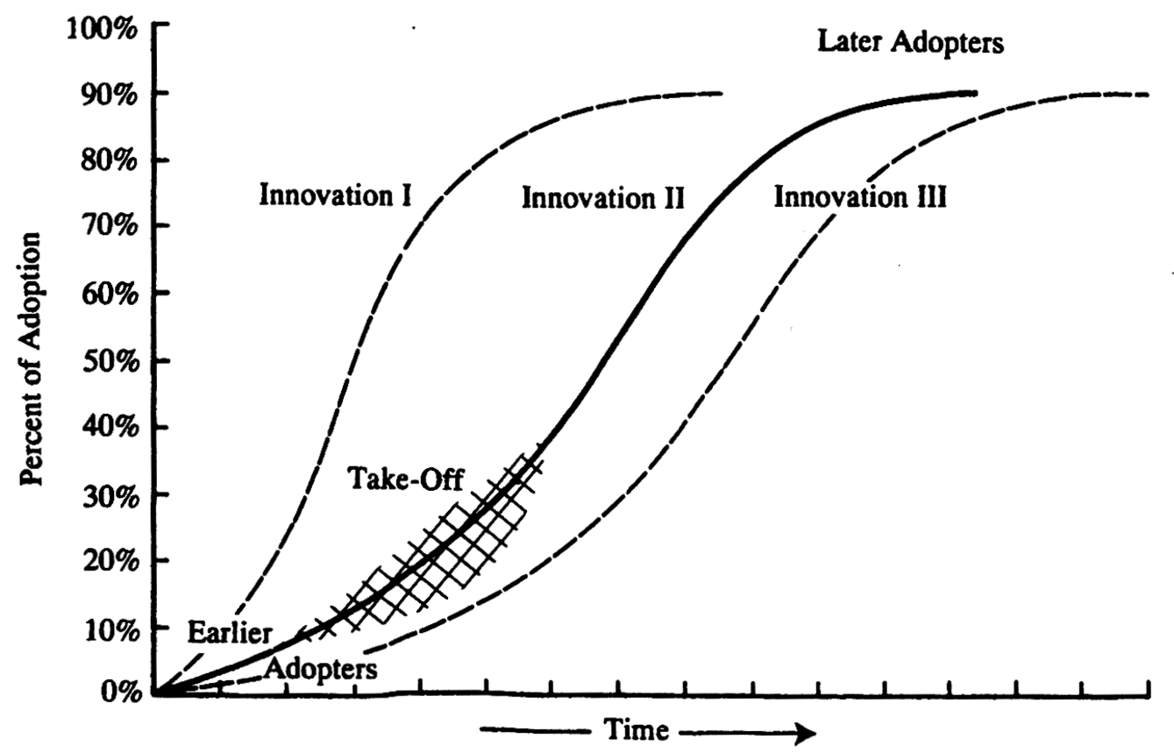

**Figure 1.** Diffusion is the process by which 1. an *innovation*, 2. is *communicated* through certain channels, 3. over *time*, 4. among the members of a *social system* (Rogers, Diffusion of Innovations, 1983, p. 11)

Rogers (1983) outlined the social system as the forth element to understanding the diffusion process which can be defined by a set of interrelated groups made up of individuals, informal groups, organisations or subsystems who have a common goal. The reason why the social system works is due to the members having a common objective, which provides the drive and binds them together to work as one. However, the social system does have a number of issues affecting the diffusion process starting with the fact it provides boundary of which the innovation diffuses through, the effect of norms on diffusion, the functions of change agents and opinion leaders, forms of innovation decisions and the possible consequences of innovation.

The earliest work carried out on the subject of diffusion occurred in the 1940s, with the critique of the theory not occurring until the 1970s. The main issue identified through diffusion research and thoroughly discussed by Rogers (1983) is that diffusion is the process to assess the adoption of an innovation after it has been developed by a “social system”. This is the recurring theme raised through the following criticisms:

1. Pro innovation bias
2. Individual or system blame bias
3. The recall problem

Pro innovation bias is the assumption that all the people should adopt an innovation in a social system, and the diffusion should occur more quickly and that the innovation is not rejected or re-invented. There have been exceptions to this criticism where an innovation has a high degree of relative advantage, which has caused the innovation to be rapidly adopted, and throughout the whole social system (Rogers, 1983; Ryan & Gross, 1943). In Rogers’ (1983) review of diffusion of innovations he cover a number of solutions to overcome some of the known biases caused by pro-innovation which related to how the data was gathered to assess the adoption of the innovation for example:

1. post hoc data gathering,
2. data gathered through the process of diffusion,
3. take learnings from unsuccessful diffusion or rejection and discontinuance of an innovation
4. data gathered prior to the development of the innovation
5. understand the motivations for adopting.

Individual and system blame bias refers to the process of the predisposition caused by the focus of the diffusion, which is typically on the technology and the process rather than the group of people it is targeting. Therefore, the suggested solution to overcome this bias is to understand the perspective of the adopter rather than simply focusing on the process to diffuse and the features of the innovation (Rogers, 1983). A more recent tactic in diffusion is to understand the benefits, which then allows for understanding the target group. This can also be explained by the analogy Rogers (1983) used:

*“… if the shoe doesn’t fit, there’s something wrong with my foot”.*

The recall problem in diffusion research relates to the issue of an adopter of an innovation being unable to remember information in relation to them deciding to adopt. This is because diffusion has typically related to researching the adoption of an innovation after it has been ‘released’ into a market, and therefore the time passed has caused the person adopting the innovation to forget or struggle remembering the steps they took, and the decisions made through to adopting. However, in saying this it is important to remember that time is also an essential element to the diffusion process as stated above (Rogers, 1983).

Another area of critique in the process of diffusion is equality. This relates to how diffusion has often ignored the socioeconomic benefits of innovation and their distribution within a social system. This aspect has been such a great area of criticism for the diffusion process that it has been a key area of development in later strategies used to improving adoption and covered in the following section (Rogers, 1983; Chamber, Pacey, & Thrupp, 1989; Robinson, 2009).

As touched on above the attributes of an innovation can have a significant effect on its rate of adoption, however, it is the adopter’s perception of the attributes being referred to here, not anyone else in the diffusion process. Rogers (1983) summarised the attributes identified by other diffusion researchers as, relative advantage, compatibility, complexity, trial-ability, and observability, rate of adoption, the diffusion effect and over adoption. While the first five attributes are self-explanatory, it is the last three listed above which are generally a little complex in their understanding. Rate of adoption refers to variables of an innovation, which affect the type of decision required to adopt, the nature of the communication channels, and social system along with the efforts of the change agent – described below - involved. The diffusion effect relates to the ‘snowball’ effect of an innovation being adopted and is closely correlated to communication networks in a social system – the greater the communication channels the faster the diffusion of an innovation. Lastly, over adoption is where experts in a field state that an innovation should be rejected, and based on the expert’s view the adopter of the innovation is persuaded to adopt, due to a wider audience trying to convince them otherwise.

Understanding how the rate of adoption of an innovation can be improved is the effect incentives. Incentives are often used to speed up the rate of adoption and these can be delivered in various forms. These forms a listed below and arranged by Roger (1983):

1. Adopter versus diffuser incentives – can be targeted towards the adopter or the diffuser e.g. change agent (as discussed below).
2. Individual versus system incentives – targeted towards either an individual or a group to which multiple individuals belong.
3. Positive versus negative incentives – to reward desired behaviours or could be used to penalise through an unwanted penalty.
4. Monetary versus nonmonetary incentives – can either be in a financially payment or through a trade of services or a commodity.
5. Immediate versus delayed incentives – to either reward an adopter at the time or used as an incentive to continue the behaviour for an extended period.

However consequently, adopter incentives lead to adoption of an innovation by individuals different from those who would otherwise adopt. Although incentives increase the quantity of adopters of an innovation, the quality of such adoption decisions may be relatively low, leading to limitations in the intended consequences of adoption (Rogers, 1983).

Understanding the elements of diffusion, the bias or flaws, the attributes of an innovation and its potential rate of adoption are useful properties to understand diffusion however, a key aspect is the entity – whether an individual or an organisation – who is aiding the adoption process. This entity is referred to as the change agent and was discussed by Rogers (1983) as the conduit operating between a source of information, being the entity who leads the adoption, and the client who is typically identified as an adopter. The change agent is required as there is typically a large disconnect caused by social and technical aspects of diffusion (Boyd, 2003). Change agents typically follow seven steps when introducing a single innovation (Rogers, 1983):

1. Develops a need for change to occur.
2. Establishes rapport for an information –exchange to occur.
3. Diagnosis of the adopters’ problems.
4. Creates intent to motivate the adopter to change.
5. Transforms intent into action indirectly through opinion leaders and peer networks.
6. Stabilises the adoption by reinforcing the motivation to adopt.
7. Create self-reliance in the adopter.

After a change agent has been identified, understanding the needs of different users of an innovation is key to refining the process of diffusion. Diffusion experts believe that an innovation targeted at a group can be broken down into five different segments based on their inclination to adopt the innovation. These groups are innovators, early adopters, early majority, late majority and laggards as illustrated in Figure 2 (Rogers, 1983)

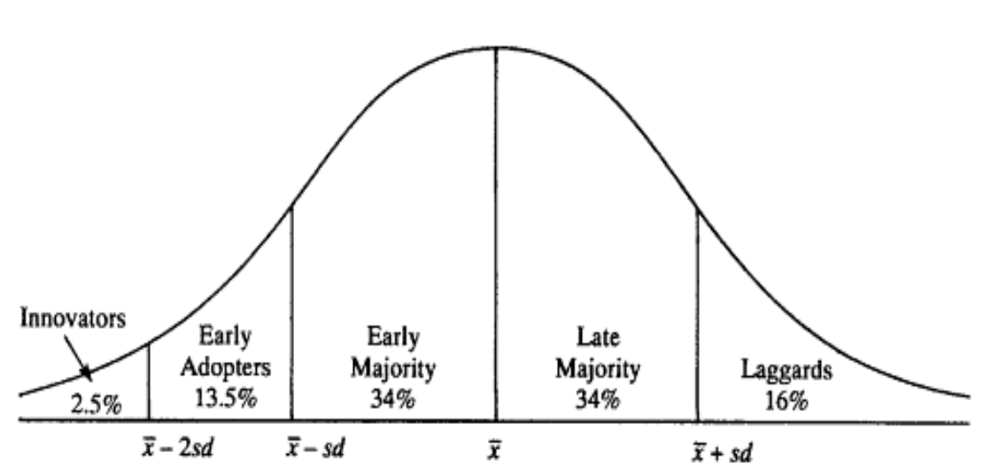

High Propensity to adopt Low

Low Propensity to resist High

**Figure 2.** Adapted from Rogers (1983, p. 247) which illustrates adopter categorisation based on the level of their innovativeness.

Innovators (who can also be known as venturesome) often begin the adoption process pouring a great deal of time, energy and creativity into developing new ideas and gadgets. They are often perceived, as mavericks due to their behaviour towards a new idea, or gadget that often makes them appear idealistic; however, no change program can work without them.

Once the benefits become apparent the early adopters (also known as respectable) become involved driven by the prospect of a strategic leap in development. This portion of a group are often trendsetters, which cause the “take off” (Rogers, 1983) effect – as illustrated in Figure 1 - as they tend to be more financially successful, connected in a network of people and well informed, which typically portrays them as more socially respected. Promoting this group through media and peer educators can allow for a successful interaction with this segment. One issue with the early adopter segment is the theory of the ‘chasm’, described as a disconnect, between this segment and the early majority. This is due to most early adopters having radically different interests and needs compared to the majority. In saying this there, is no consensus of views on this theory with Roger (2003) disagreeing and stating that the innovativeness theory is a continuum with no disconnect. All the same, the ‘chasm’ is perceived as a useful theoretical construct warning that one size does not fit all. Conversely, it is not persuasion causing an idea or gadgets to spread; it is whether it is been simplified, made cheaper, improved compatibility and more advantageous

The following segment of a group are the early majority, who are also defined as deliberate. This group are typically very pragmatic and comfortable with progressive ideas but require solid proof of benefits. The proof is required to come through industry experts hearing words such as *“industry standard”* (Robinson, 2009). This group require guaranteed performance, with little time commitment, learning and disruption, which is also cost neutral or has a short payback period. When discussing ‘innovations’ to this group the key aspects are “plug-and-play”, “user-friendly” and “value for money” (Rogers, 1983; Robinson, 2009).

The second to last segment of a population are the late majority (often referred to as the sceptical group). Due to this segment of a group disliking risk and feeling uncomfortable with new ideas, their only real drive is fear. Hence playing upon the fear of not fitting in with mainstream or established standards can be used to influence their drive for adoption. Countering criticisms from the next group (laggards) will be one way to convince this group (Rogers, 1983).

The last group to adopt an innovation are called laggards and described as traditionalists. This group see high risk in ‘new’ innovations and often spend a lot of energy thinking of arguments to counter the diffusion through the previously described segments. However, this segment can also be correct on occasions where an innovation is not cost effective or less time consuming and therefore their reasoning and possible justification for not adopting an innovation may lead to an even better idea and therefore making them innovators in their own right. During the early stages of adoption of an innovation laggards typically do not get given a great deal of attention, but when it comes to convincing the early and late majorities addressing the views of laggards can aid in reducing or extinguishing the fears of the late majority (Rogers, 1983).

It is vital to consider the groups within a population who are adopting an innovation as the percentage of the population will guide you in knowing which segment is being adopted and the tactics needed to encourage them to change. Furthermore, Robinson (2009) clearly summarised that not every laggard on a specific innovation is guaranteed to be a laggard for another innovation, and the same for the innovator segment. Black (2000) agreed with this sentiment by stating it would be a tiresome way to live your life if you were always behaving as an innovator or laggard due to the level of energy required. Therefore, it is important to understand that most people typically fall into the majority categories and on occasion identify as an innovator or laggard (Rogers, 1983).

### Current state – extension strategies

Although Rogers (1983) has outlined the process of diffusion to understand the strategies to increase adoption of technology the role has since evolved into the theory of extension in society however, it has yet to come to a universally agreed definition. Marsh and Pannell (1998, p. 2) describe extension in the agricultural sector as:

*“…public and private sector activities relating to technology transfer, education, attitude change, human resource development, and dissemination and collection of information.”*

The Australasian Pacific Extension Network (2016) describe extension as follows which is also further discussed below:

*“Extension is about working with people in a community to facilitate change in an environment that has social, economic and technical complexity. This is achieved by helping people gain the knowledge and confidence so they want to change and providing support to ensure it is implemented effectively.”*

Although there is universally agreed definition for extension there is an emerging shift driving the development of extension strategies that was summarised by Clements (1999):

*“…emphasis on reporting numbers of contacts to reporting measured impact will be a challenge to some of us. Certainly, it has implications as we plan our programs, which should include fewer programs, more follow-up sessions, and specific time dedicated to measuring change. Successful documentation will likely impress legislators and funders and assure the future of Extension programs.”*

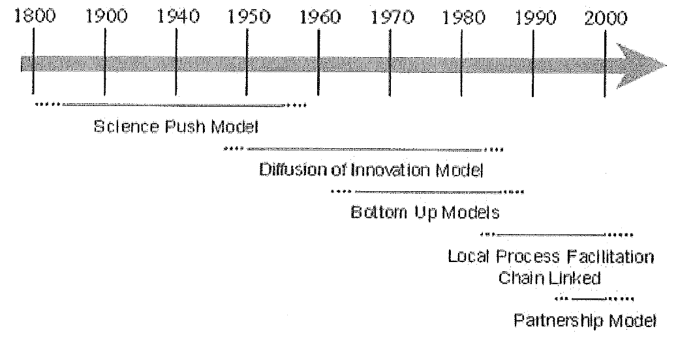

**Figure 3.** Progression of extension models sourced from DairyNZ (2014) and adapted from (Coutts, 1997; Röling N. E., 1991; Schulz, 2001)

With the realisation of ‘top-down’ models of extension not fully meeting the needs of adopters, ‘bottom-up- models of extension emerged due to the concept that the adopter wanted to be involved in the research, development and extension process.

Models which started to emerge in the 1990s (Figure 3) are characterised by participatory involvement of stakeholders in program planning, development and implementation with Röling & Engel (1991) summarising these models in the practices of Agricultural Knowledge and Information Systems (AKIS) (Coutts, 1997). The AKIS theory resulted from the perception that relationships between stakeholders should be more integrated to develop an effective extension program. Schulz *et al.* (2001) discussed the partnership model of extension, which used a case study to demonstrate the theory of the AKIS model working effectively.

A leading organisation in the area of extension which involves New Zealand is the Australasian Extension Network (APEN), who have also outlined the latest principles of extension as illustrated in Figure 4. These principles follow the latest theory of participatory involvement and include partnership, engagement, empowerment, capacity building, technical support, cultural awareness and utilising local resources (Australasia Pacific Extension Network, 2016). These principles aim to improve the capability of people and their tolerance to change and maintain the energy of the process. APEN (2016) summarises these principles by stating that they may vary when applied to differing situations, with the best approach being the one that works for all involved, maximising efficiency and effectiveness.

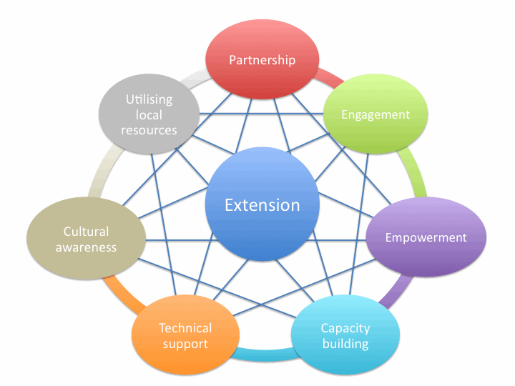

**Figure 4.** Diagram demonstrating the philosophy of the Australasian Pacific Extension Network (2016).

## Extension used in farming

As discussed in Rogers (1983) review of diffusion strategies this process has been applied to numerous fields including the rural sector, which can also claim major credit for initially forming large shifts in diffusion research. The strategies outlined by Rogers (1983) have been applied and transformed in the rural sector, with many strategies created however, a predominant number of models are now utilised. Four prominent strategies are linear ‘top-down’ transfer of technology; participatory ‘bottom-up’ approaches; one-to-one advice or information exchange; and formal or structured education and training (Black, 2000).

### Linear ‘top-down’ transfer of technology

The perception for many years was that the linear ‘top-down’ transfer of technology was the dominant model for extension in agriculture. As Black (2000, p. 493) stated this was due to:

*“…the assumption that new agricultural technologies and knowledge are typically developed and validated by research scientists”.*

The issue with this method of extension is that it focuses on ‘early adopters’ (Figure 2) which is why it is on occasion referred to as the linear adoption or diffusion model as detailed by Rogers (1983).

A downfall to this strategy is inadequate attention is often given to the long-term economic, environmental and social impacts of the technologies being adopted (Vanclay & Lawrence, 1995). Furthermore the ‘top-down’ approach is assumed to be problematic as a fundamental step in this model is that after the ‘early adopters’ have applied the technologies these practices will inevitably diffuse down to the majority of farmers. Examples of technologies that have had success using this model are high analysis fertilisers and tractors (Rogers, 1983).

This strategy is also argued to favour farmers who have better access to material, intellectual and social resources (Röling, Ashcroft, & Chege, 1976). There is also doubt relating to the use of this strategy with complex practices as it has really only been used with singular technology innovations such as tractors and high analysis fertiliser as earlier stated. Further doubt in the use of the ‘top-down’ model exists when comparing productivity gain technologies with sustainability and environmental improvement technologies although the ideal situation would see both objectives being achieved (Buttel, Larson, Gillespie, & Rural Sociology Society, 1990).

### Participatory ‘bottom-up’ approaches

Due to the poor ability of the ‘top-down’ strategy to transfer technology through the industry alternative models have been created. Since the late 1970’s many bottom up approaches have been developed and these have been summarised by Black (2000) from earlier work by Cornwall, Guijt, & Welbourn (1993) and other sources and shown here in Table 1.

**Table 1.** An adaption of the selection of participatory methodologies of the 1980s and 1990s summarised by Black (2000) and originally sourced from Cornwall, Guijt & Welbourn (1993) and Pretty & Chamber (1993).

|  |  |
| --- | --- |
| **Acronym** | **Participatory approaches** |
| AEA | Agroecosystems Analysis |
| BA | Beneficiary Assessment |
| D&D | Diagnosis and Design |
| FPR | Farmer Participatory Research |
| FSR | Farm Systems Research |
| FSR/E | Farming Systems Research and Extension |
| PRA | Participatory Rural Appraisal |
| PRAP | Participatory Rural Appraisal and Planning |
| RAAKS | Rapids Assessment of Agricultural Knowledge Systems |
| RRA | Rapid Rural Appraisal |

The participatory theory challenges the starting point of the ‘top-down’ approach of knowledge, problems, analysis and priorities of scientists and instead starts with the knowledge, problems, analysis and priorities of farmers and their families (Cornwall, Guijt, & Welbourn, 1993). Therefore, rather than fit a solution to a problem and then attempting to gain the buy in from farmers and practitioners the farmers and practitioners share their issues and problems and then a solution is created to fit the scenario. However, there are mixed views over the ‘bottom-up’ approach with specialists in rural sociology such as Chamber, Pacey, & Thrupp (1989) advocating it is complementary to the ‘top-down’ approach and other reports from Cornwall, Guijt & Welbourn (1993), Pretty & Chamber (1993) and Marsh & Pannell (1998) stating it is sufficient to use on its own. Black (2000, p. 495) goes on to summarise that:

*“They typically make use of group processes, which have various advantages such as: the pooling of skills, knowledge, experience and other resources; drawing on a wider spectrum of ideas and thus reaching better solutions than individuals; integrating information from various sources, including knowledge from outside the group; economies of scale; risk sharing, and thus the development of potentially more adventurous solutions to problems.”*

Conversely, there are also critics who do not advocate the use of the ‘bottom-up’ approach at all as Vanclay & Lawrence (1995) stated the nature of certain problems means farmers may struggle to identify the issue as a broader set of knowledge and experience may be required. As an example, Vanclay and Lawrence (1995) went on to outline the ‘bottom-up’ approach would fall down as an appropriate method when applied to environmental problems. From Black’s (2000, p. 496) review of extension theory and practice he summarised that this is a consequence from “competing conceptions of community needs” dependent upon the interests of the various groups and individuals involved with the majority of the approaches as outlined in Table 1 underestimating ,or completely ignoring these differences.

Other points of risk when using the ‘bottom-up’ approach is the possibility of poor diffusion of the information due to a lack of skill to document and then disseminate the knowledge (Marsh & Pannell, 1998). There is also a risk of overloading farmers who are typically more eager to participate as the cost of their time or financial input may offset the benefits (Black, 2000). As there are as many reasons to use group-based approaches through the likes of the ‘bottom-up’ method as there are not to use them, it should not be regarded as the one and only strategy. Black (2000) summarised this view by stating:

*“Belief in a ‘participatory fix’ may be just as naïve as belief in a ‘technology fix”.*

### One-to-one Advice

There is a current trend in the approach of one-to-one declining, which is being driven through the reduction of government investment (Black, 2000). This government investment has declined worldwide over the past 3 decades (Marsh & Pannell, 1998) and withdrawn completely in New Zealand from any direct contributions. As the environmental impact of farming activities draw more attention, the lack of government investment becomes a complex issue as the benefits of improvements can extend past the farm boundary (Black, 2000).

While the role of private entities offering extension services increase there is a growing concern regarding the relationship between the organisation and the public sector. There is also concern over the market having a lack of co-ordination and co-operation between agencies in information generation, validation and exchange (Black, 2000). Marsh and Pannell (1998) evaluated that through the lack of co-operation and co-ordination fragmentation will occur between the innovators and the extension specialists from the various organisations and agencies, being different government departments and between public and private entities.

### Structured education and training

There is a real lack of published reports relating to the level of education attained by New Zealand farmers as concluded by Bailey (1992). Bailey (1992) also completed a report for the Kellogg Rural Leadership Programme and it appears there has been very little progress made on filling this gap in research. The most commonly cited work concerning formal education attained by New Zealand farmers Ken Moore carried out in 1990 titles *“Learning on the Farm”* which is now fairly dated. Moore (1990) derived a relationship between formal education and improved farm management ability however; farmers’ ability to adopt new technology due to attaining a higher level of education was not assessed through the survey undertaken for the review.

From an Australian study on farmer’s preference as to the content and delivery of planned learning Bamberry, Dunn & Lamont (1997) summarised the following points:

*“****1.*** *Content – meeting specific needs for knowledge and skills relevant to current and future developments, including learning skills;*

***2.*** *Approach – short, modularised courses encouraging participation, project-based learning, developing competencies, practical, measurable outcomes;*

***3.*** *Delivery – flexibility, to accommodate seasonal work demands, home study plus local support where possible, provision for some social interactions.”*

However, additional points to be considered to the above summary can be explained through leveraging the VARK (visual, auditory, reading and kinaesthetic) model (Fleming & Baume, 2006). The most popular learning methods for farmers were outlined by Kilpatrick (1996) and involved visual, auditory and kinaesthetic methods with reading the least preferred style. Napier and Scott (1994) came to a similar conclusion with project based and hands on learning be preferred by farmers. Kilpatrick (1996) further expanded on the above, indicating that social interaction through group learning can motivate participation along with being part of the extension process.

As with the three previous approaches there have been mixed conclusions on the relationship between formal education and good farm management. However, Kilpatrick (1996) concluded that farm profitability and viability could be improved by:

**1.** Having agricultural qualifications within the farm management team; and

**2.** Farmers’ participation in training events such as field days, seminars, conferences or industry meetings.

### The extension spectrum

As is becoming clearer through the review of extension and adoption of innovations it is not always clear on what approach to take when practicing extension. What typically occurs is a combination of methods as Figure 5 illustrates. Campbell & Junor (1992) stated, that as an innovation becomes more complex, the development of the skills of the individual or social system adopting the technology needs to also increase. Figure 5 demonstrates the situation where an idea increases in complexity and a greater level of skills are required bringing to the fore people’s ability to experiment, learn and develop, and less requirement for technical capability, however this generally still needs to be developed. The four strategies outlined in the above section can also be identified in Figure 5 with the ‘top-down’ approach falling into technology transfer, problem solving represented by the ‘bottom-up’ approach, education as ‘one-to-one advice’ and human development represented as ‘structured education and training’ (Black, 2000).

Increasing level of people skills

Increasing complexity of situations

Technical know-how

Human development

Education

Problem solving

Technology transfer

**Figure 5.** The extension spectrum (Campbell & Junor, 1992)

### Technologies and other techniques used to further develop extension approaches

An area developing in extension is the impact of information technology (IT) and how the digital era we now live in is altering the way extension strategies are implemented. Since the 21st century, there has been great changes in IT that has increased the access and capability of extension and information exchange. However, constraints still exist with the lack of up to date technology in the form current state telecommunication infrastructure. This being said the opportunities developing with internet connectivity should not be underestimated. On the reverse of this is the reliability of the information, and potential information overload, which should be a key focus for future extension research. However, building on the previously discussed section, the use of IT could be combined into future extension approaches about how to critically analyse and filter information from these sources. In saying this, Black (2000) summarised by stating that until farmers use the internet for day-to-day communication it is unlikely they will use the internet for more complex searches. In addition, Da Rin and Groves (1998) reported from an Australian study two years earlier that farmers were starting to use the internet for communication purposes e.g. email, and that the impeding change in the rural sector was starting to occur.

Further to new ways of practicing extension are other activities, which extension workers may carry out but not classified as extension practices to aid the adoption of innovations (Australasia Pacific Extension Network, 2016; Boyd, 2003). In agriculture, they may be involved in applied research, marketing, providing specialist services (free and charged) and helping form regulation. However, as most extension workers in countries such as New Zealand, are employed or contracted by corporatised companies, their employer will dictate the work carried out and therefore they may have many different roles. Figure 6 demonstrates such a situation however; this example is for a government agricultural extension officer in Australia. Here the example identifies that an individual in such a role spends the majority (~60%) of their time on extension activities, a quarter of their time on field research and the remainder split between development and promotional activities (Australasia Pacific Extension Network, 2016).

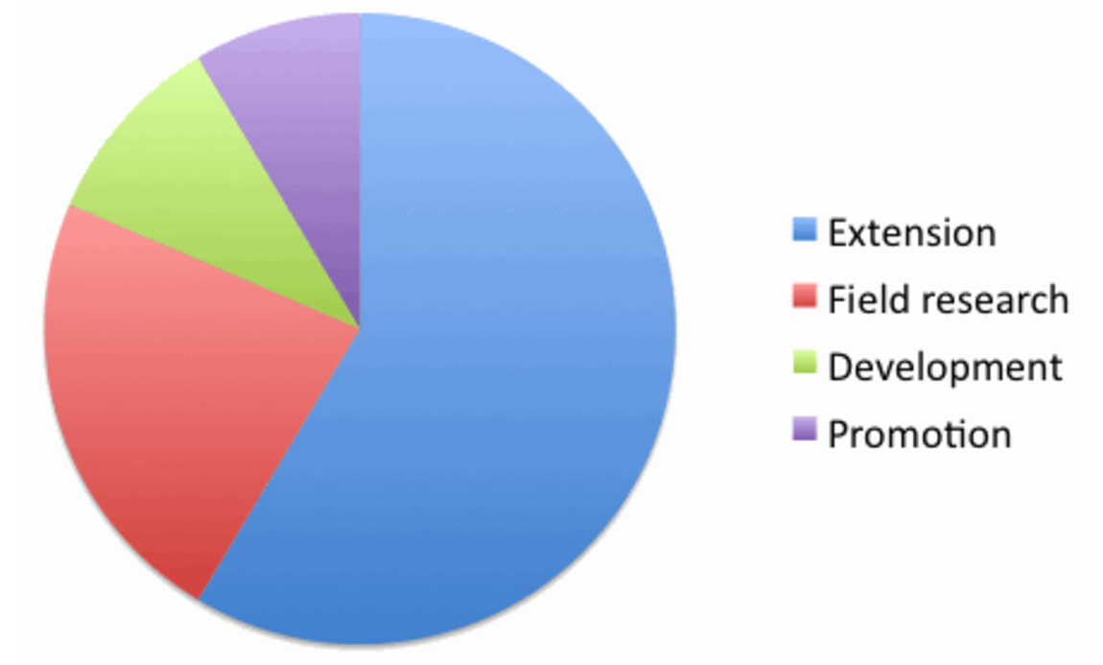

**Figure 6.** Agricultural extension officer roles (Australasia Pacific Extension Network, 2016).

## Conclusion

Precision farming or the management of variability in agricultural production systems emerged in the 1980’s as a way to apply the right treatment, in the right place, at the right time (Corwin & Lesch, 2003). Increasing awareness of variation in soil and crop conditions, combined with the advent of the technological revolution such as GPS and sensors, serve as the main drivers (Brisco, Brown, Hirose, McNairn, & Staenz, 2014; Griffin & Lowenberg-DeBoer, 2005). Initially PF was used to adapt fertiliser recommendations to vary soil nutrient status across a paddock. Since then, additional practices have evolved, such as automatic guidance of vehicles (mainly tractors), product traceability, on-farm research, and software for the overall management of agricultural production systems. In New Zealand PF has been more successfully applied in monoculture crops such as can be found in the horticulture, viticulture and arable industries. This trend has been put down to the ease of managing such an agricultural system compared to a mixed crop or grazed farm system (Yule & Grafton, 2016). Despite the differences in the types of technologies and areas of adoption, the goals of precision farming are threefold. First to optimise the use of available resources to increase the profitability and sustainability of agricultural operations. Second to reduce negative environmental impact. The third to improve the quality of the work environment and the social aspects of farming and relevant professions (Barrett, 2002).

The down fall to PF technologies is that the benefits are not always easily identifiable, communicated or adopters persuaded to make the change, therefore extension strategies are required to be developed. Numerous extension approaches have been developed since Rogers (1983) carried out a review in the 1980s. With four predominant approaches outlined by Black (2000) and discussed:

1. linear ‘top-down’ transfer of technology
2. participatory ‘bottom-up’ approaches
3. One-to-one advice
4. Structure education and training

The issue as raised through the work carried out by Rogers (1983) is that the majority of the earlier diffusion strategies focus on post release of the innovation into a market and the documentation of the program (Clements, 1999; Rogers, 1983). The issue with this is that it is often too late to have a large enough effect on improving the adoption however; it does provide the opportunity to gain an understanding of why the innovation was adopted in the first place. Therefore the new strategies now referred to as approaches, of extension should be considered as more relevant as these attempt to focus on aiding innovation adoption prior to development or upon release of the innovation into a market.

Currently, there are mixed opinions regarding preferred extension approaches, regardless of whether they are used in the rural sector or not, there appears to be a growing trend in that:

*“…there is no one best way of delivering education and training. A variety of delivery methods and training programs should be available”*

as Kilpatrick (1996, p. xii) concluded and this view was consistent with the findings from Black (2000, p. 493) who stated,

*“…no single model or strategy is likely to be sufficient by itself”*.

Therefore, the conclusion drawn from this review is that no one-extension approach will fit every innovation developed and generally, a combination of approaches will work best. Furthermore, there are aspects such as identifying the target market and understanding how individuals or social systems will adopt innovations, which can have a greater impact than simply trying to follow an extension approach (Boyd, 2003).

# Introduction

The following section of this report outlines two case studies and attempts to apply the learnings from the above sections to gain insights into the adoption of PF technologies used overseas and in New Zealand.

## N-Sensor®

The N-Sensor® is a tractor-mounted tool that allows farmers to measure a crop’s nitrogen requirement as the tractor passes across the paddock and to vary the fertiliser application rate accordingly. The N-Sensor® ensures that the right and optimal rate of fertiliser is applied at each individual part of the paddock. It has become the benchmark technology for precision agriculture (Yara International - UK Ltd, 2015). Yara International (2015) state that through practical experience the N-Sensor® can increase yields by up to 10 percent over standard farm practices, boosting profits and minimising environmental losses.

### Increase nitrogen efficiency

Plants need the proper nutrients to reach their natural growth potential, with modern fertiliser practices aiming to achieve this goal. However, this practice is becoming more complex with the ever-refining practices known as precision farming (PF) occurring on farm, driving towards even greater precision. It is just as important to match the amount of nutrients from fertilisers, to the correct level of growth, avoiding costly excessive application. There is an environmental cost to incorrect application, with excess nutrients comes leaching and runoff into waterways, leading to adverse effects on the environment.

The N-Sensor® concept allows farmers to increase the efficiency and accuracy of fertiliser inputs to maximise profitability and minimise impact on the environment. Nutrient requirements of the crop fluctuate greatly between paddocks, but can also vary widely within a paddock. Engineers at Yara developed the N-Sensor® for the site specific management of nitrogen application. The N-Sensor® is mounted on the tractor roof and is 'on the move' measuring light reflectance from the crop, translating this into an optimum application rate enabling the application equipment to apply the required rate of nitrogen for that specific part of the paddock. The N-Sensor® determines a crop's nitrogen demand by measuring the crop's light reflectance. Using this information the N-Sensor® can measure the crop, translate the data into an application rate and send a signal to the spreader or sprayer rate controller, which will adjust the levels of application. If the operator wants, they can review and alter the average application rate before spreading begins (Yara International - UK Ltd, 2015).

### Benefits of using the N-Sensor®

There are six stages of the N-Sensor®, which can be outlined as overarching benefits when using the technology.

1. Increased Gross Margin per hectare – Variably applying nitrogen according to the crop requirements means that the optimum rate of nitrogen is achieved for all areas of the paddock resulting in increased gross margin.
2. 'Real Time' Sensing and Application – Allows for crop information to be collected, processed and applications made on the go.
3. Improved Yield and Quality – Applying the optimum rate to all areas of the paddock-improving yield (3.5% increase – refer to Table 2) and also significantly evens up the grain, factors which both increase profitability with 12-20% improve in combine efficiency.

**Table 2.** Based on an average 8.5 ton/ha grain yield, a 3.5% yield increase using the N-Sensor® and a $350/ton grain price, farmers could expect to receive the following value in return

|  |  |  |
| --- | --- | --- |
|  | **200 ha farm** | **400 ha farm** |
| **Value of additional yield** | $20,825 | $41,650 |

1. Better, Use of Nitrogen – Applying the exact crop nitrogen requirements improves efficiency and economics and minimizes the effect on the environment. Can be used independently or in conjunction with GPS - By measuring the crop and applying the recommended application in one operation, the N Sensor works independently of GPS systems. However, where nitrogen application maps are required it can easily be linked to a GPS system.
2. Ease of use – designed to be user friendly. The in cab computer (Figure 7) is clear and simple to operate and once set up works automatically while spreading or spraying.
3. Improved harvest conditions – Even crops can result in quicker and simpler harvest conditions. Flow of crop into the combine is improved and more uniform grain moisture means less drying will be required.



**Figure 7.** In cab computer used to receive data from the N-Sensor® and automatically control the spreading and spraying (Yara International - UK Ltd, 2015).

An additional benefit to using the N-Sensor® is gaining access to Yara’s ‘Sensor Office’. The Sensor Office provides a platform (Geographical information system - GIS) to create maps for the users farm and to then overlay data captured by the N-Sensor® followed by the proof of application maps post apply the fertiliser or spray. The benefits from a farmer’s perspective are outlined as follows:

1. Visualisation of N-Sensor® - application maps

Sensor Office is an internet application used to visualise nitrogen levels sensed in the biomass as captured by the N-Sensor® (Figure 8). In addition, it allows creating maps of the relative biomass distribution of the paddock. It is easy to use and no software installation is necessary, as it is a web-based platform.

1. Sensor Office – a specialised GIS for N-Sensor® data

Sensor Office is a specialised GIS (Geographical information system), which focuses on the main functions required to get a simple nitrogen fertiliser application and biomass map of the N-Sensor® data (Figure 9). In addition, an inexperienced GIS-user will soon be able to document their nitrogen fertiliser rates in a professional map. Sensor Office guides you through the software systematically. The processed map can be printed or downloaded.

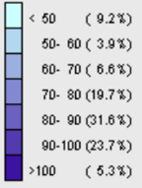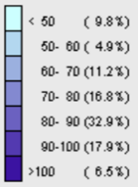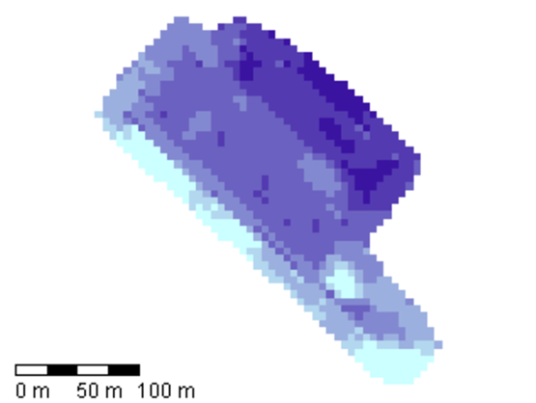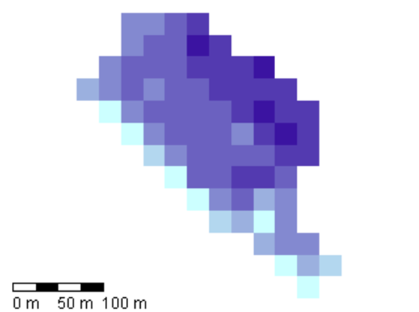

**Figure 8.** The Sensor Office on Yara Internationals website can create raster maps to use with a job-controller for applying fertiliser or sprays. These particular maps have 6m and 24m pixels, from left to right (Yara International - UK Ltd, 2015).

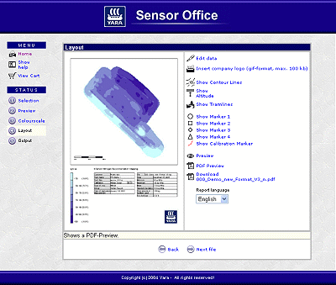

**Figure 9.** Home screen of the Sensor Office on Yara Internationals website used to process data from the N-Sensor® (Yara International - UK Ltd, 2015).

## Global Positioning Systems - GPS

Global Positioning Systems (GIS) are used through agricultural systems and is generally perceived as the instigator of PF as we know it today. Without GIS, the majority of PF activities would not be functioning or at the very least limited in their capability (Yule & Grafton, 2016).

Implements for site-specific management are available for most tasks, including tillage, mechanical weeding, and fertiliser application and other agrochemicals (Gebbers & Adamchuk, 2010) as illustrated in Figure 10. Up until now, GPS based vehicle guidance also known as autosteer has been the most widely used precision farming technology (Heraud & Lange, 2009). Allowing the operation of agricultural vehicles along parallel tracks or on predefined paths, resulting in less stressful driving, significantly fewer gaps and overlaps and less soil damage caused from compaction. Field robots are the next logical step in the automation of crop production. For the latter stages of this report, the focus of GPS use will centre on the utilisation for autosteer capability to provide the opportunity of a focused discussion in the following sections.

GPS

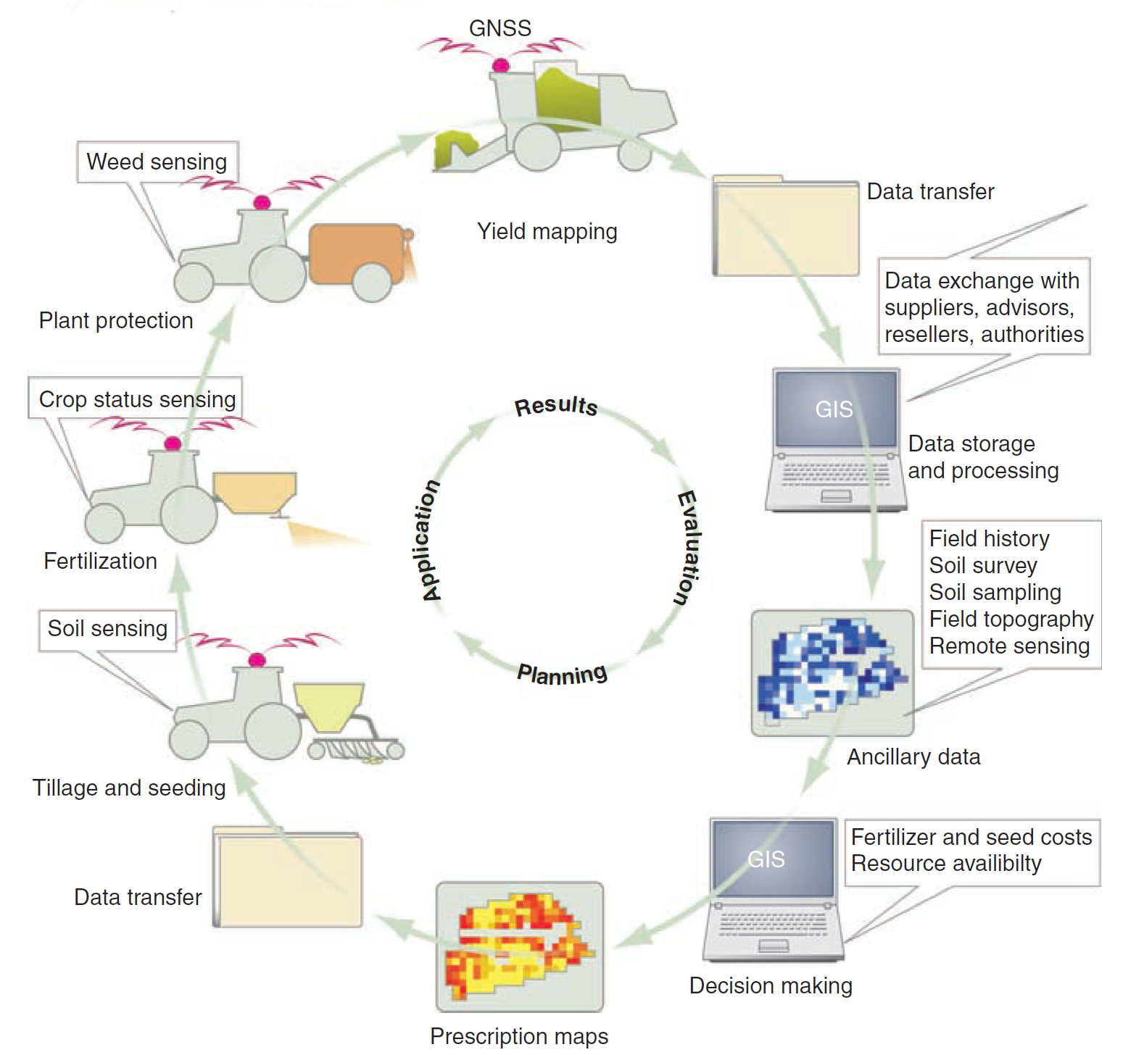

**Figure 10.** Precision agricultural information flow in crop production adapted from (Gebbers & Adamchuk, 2010).

Other areas where GPS is also prominently used is soil testing, flying unmanned aerial vehicles (UAVs) (Griffin, Lambert, & Lowenberg-DeBoer, 2005) and livestock management (Pedersen, Fountas, Blackmore, Gylling, & Pedersen, 2004). GPS is used in soil testing when marking soil transect lines to ensure the same soil transect is sampled from one season to the next limiting variation in the soil sample gathered. This information now days can be overlayed onto a GIS platform for spatial representation and ease of management. UAVs also use GPS to guide their movements when flown autonomously along a predetermined path – similar to the autosteer described above. Livestock management is a growing area using GPS where a sample or the entire herd or mob of animals, have an electronic identification tag which can communicate via GPS and to aid locating them in extensive farmland. Although other areas of utilise GPS as outlined above for the remainder of this report when GPS is referred to it will be in relation the autosteer functionality stated above.

# Method

In conjunction with the literature review, two technologies currently available in the rural sector used for precision farming were used as case studies. These technologies were chosen based on their level of perceived adoption, and ease of access to information on the individual technologies. The technologies used as case studies were:

1. N-Sensor® – produced by Yara International
2. Global position system (GPS) – autosteer capability

The objective was to compare and contrast each of the tools used in the rural sector regarding the introduction and diffusion of the technologies through the industry. Furthermore, a comparison between two countries of the introduction and extension strategies used for each technology will also be investigated.

# Findings and Discussion

The two technologies investigated with regards to their current rate of adoption in the agricultural sector were the N-Sensor® and GPS use for autosteer capability in farm vehicles. The problem with access to data quick become apparently where there was limited adoption data for PF technologies in New Zealand for both technologies investigated. This finding was not unusual as stated by Yule and Grafton (2016). This being said the N-Sensor is still in its infancy of commercialisation as described by Yara International (2017). Conversely, the proliferation and multiple suppliers (Heraud & Lange, 2009) of farm machinery in New Zealand let alone overseas meant it was impossible to obtain accurate data on adoption of autosteer in on farm vehicles due to the perceived commercial sensitivity around information becoming available. Therefore the discussion will primarily focus on the N-Sensor® and where possible GPS use with reference to autosteer will be referred.

## N-Sensor®

In terms of adoption rate the N-Sensor® is still in its infancy in being utilised by farmers and advisors all over the world with 1,771 units sold as at 2016 as illustrated by Figure 11 (Yara International, 2017). The adoption rate in comparison to other agricultural technology would place it predominantly in the innovator and early adopter and just moving into the early majority categories identified by Rogers (1983). The reason for this is that in the case of the United Kingdom (UK) ~16% of the total area which could adopt the N-Sensor® is currently using the technology.

**Figure 11.** N-Sensor® adoption by country up until 2016, including the ALS model, which is in 36 countries (Yara International, 2017).

Table 3 identifies 300,000 ha of land in the UK has been fertilised using the N-Sensor® and the total area of arable land (which is the market where the N-Sensor® is targeted) is 4.8 million hectares (Department of Environment Food & Rural Affairs, 2016) which equates to 16% of the current total market. This representation of the current adoption of the N-Sensor® provides insight into who has adopted the technology to date and who is needing to be catered for with regards to extension approaches today onwards in the UK. As outlined by Robinson (2009) and Rogers (1983) the next steps are to understand how to connect with the next adopter categories.

**Table 3.** Estimated area (hectares) of N-Sensor® based fertilisation in predominant European markets (Yara International, 2017).

|  |  |  |
| --- | --- | --- |
| Country | No. of N-Sensor® units | Acreage with N-Sensor® fertilisation (ha) |
| UK | 260 | 300,000 |

Yara International (2017) has stated that to date minimal deliberate extension strategies have been developed or deployed to aid the adoption of the N-Sensor®. In saying this the sales structure of N-Sensors® and their associated services can also be accessed through advisors in the industry in the UK who may have been carrying out the own independent extension strategies. However, as the N-Sensor is still being adopted by the market in the UK and is still relatively ‘new’, the level of information, which has been provided, has been sufficient for the current target audience of the innovators and early adopters. The current aids developed are information sheets on the technology which cover off in detail the features with the benefits only just be quantified over the last few years. Based on the extension strategies to date, whether deliberate or not, some thought should be considered when approaching the next adopter categories to aid the adoption of the N-Sensor®.

As the technology has already been developed, it provides little scope to involve the users of the technology in the development stage of the innovation and therefore leaves few options to engage in other methods of extension as discussed and recommended by Black (2000) and the Australasian Pacific Extension Network (APEN) (2016). However, opportunities still exit for the UK market that include but are not limited to, leveraging communication networks, foster peer-to-peer communication and in field displays of benefits (Boyd, 2003) (Fleming & Baume, 2006). Other activities, which may also aid but are outside the typical approaches of extension, are marketing and facilitation of industry demonstrations and discussions (Australasia Pacific Extension Network, 2016).

When investigating the current adoption of N-Sensors® here in New Zealand Yara International were not able, determine the current number sold within the country. Their perception of the New Zealand market was that it was still in a commercial development stage attempting to understand the ‘fit’ within the agricultural system and benefit of the technology. Therefore, this places the N-Sensor® in the innovator category identified by Rogers (1983) and as the UK market has already progressed further into latter adoption categories, a New Zealand extension approach can utilise and leverage the current material available to aid the adoption. Furthermore, as another social system (Rogers, 1983) , that being the UK, has worked through some of the hurdles of the adoption of the technology, the adoption rate in New Zealand should theoretically be faster if the drive and appropriate environment was present here in New Zealand.

## GPS - autosteer

The current rate of adoption of GPS in relation to autosteer is exponential as it is now standard for all agricultural tractors to be manufactured with this capability (Heraud & Lange, 2009). As this is the policy for this type of agricultural machinery, it is hard to understand the actual use and impact of autosteer in the agricultural industry. There have been reports from states in the United States reporting as high a use of autosteer as 83% of the market (Griffin, Lambert, & Lowenberg-DeBoer, 2005). However, the flow on effect of comparing adoption of technologies in the United States to New Zealand is that the agricultural systems are typically perceived as different. This being said there have been some reports of (Yule & Grafton, 2016) of positive adoption for autosteer in New Zealand regardless of the difference between the two above-mentioned countries.

As autosteer capability is now being provided regardless of whether the adopter wants the technology or not is now playing against the laggards in the adopter categories. Since the laggard category identified by Rogers (1983) starts at 84% the current reported rate of adoption of autosteer in the United States is closely approaching the last adopter category. With the laggard group in the United States now essentially being told that it is the status quo for technology and ‘if you do not adopt the technology you will be left behind’ which is the factor of fear identified by Robinson (2009) to motivate the current adoption category and a portion of the laggards.

Considering that, New Zealand is reported to be late adopters on PF technologies compared to the rest of the world (Yule & Grafton, 2016). New Zealand should be able to take some learnings from the other nations such as the UK who are also reported to have higher adoption rates of autosteer to overcome issues they had to navigate and increase the rate of adoption of the technology here in New Zealand.

## Comparing adoption of technology between New Zealand and overseas

Prior to carrying out this report the idea of the country, where an innovation is being adopted was perceived to have an effect on the rate of adoption and the extension approach applied to aid the adoption process. Therefore, the influence of a country on the adoption of a technology does not have a great effect. However, what is important are the elements to diffusion outlined by Roger (1983), extension approaches described by Black (2000) which included the participatory ‘bottom-up’ approach and additional activities to extension as outlined by APEN (2016). When a country can influence the adoption of a technology is through cultural beliefs and standards, which may influence and adopters decision of whether or not to adopt an innovation (Australasia Pacific Extension Network, 2016). Through the reading carried out for this report there was no such reported example in the rural sociology research field, however there were a number for the medical and health research fields.

# Conclusion

Precision farming is a growing trend in the agricultural sector both overseas and here in New Zealand. Precision Farming can relate to any aspect of the agricultural farm system with new technologies be developed constantly to improve multiple facets of the farming business, whether it is environmentally, financially or socially focused.

Understanding the adoption categories identified in the 1980’s simplifies targeting portions of the market when aiding the adoption of the technology and explains why mass adoption does not occur when an innovation come onto the market. Taking the learnings from the initial work on sociology and applying them to an agricultural context creates a great approach to develop extension strategies tailored to the rural sector.

Although this report used two case studies as examples of how adoption has occurred and whether anything can be learnt for future technologies it has created a great foundation for upstanding the possible approaches and potential flaws in extension approaches.

The major limiting factor to applying the case studies in this report was the lack of data on adoption rate of technologies used in PF however; this was more prominent in the New Zealand context.

As stated in the discussion the influence regarding the impact of country on the adoption of a technology is generally not a concerning factor when it comes to the adoption. That being said an area outlined by the Australasia Pacific Extension Network (2016) is cultural awareness:

*“Different cultures sometimes communicate and do things in different ways. To facilitate change extension workers have to manage these differences to ensure they do not impede the change process.”*

# Recommendations

Based on this study, the following recommendations are made through the researched evidence and discussion. Although the following has been revealed, this report has only scratched the surface in the area of extension and precision farming, where some people spend their entire lives researching. Therefore, it is advised these recommendations are taken for what they are, future work carried out in the area of precision farming, and extension strategies should be supported.

1. Greater attention and emphasis should be placed on developing extension approaches through the development of an innovation.
2. Identifying target markets and involving the potential adopters through the development of the innovation is reported to have a great improve on rate and success of adoption.
3. Data of technology adoption should be captured on a national level to provide insight into rates of adoption and technology transfer within the agricultural industry.
4. Identified through the literature review, the lack of knowledge around the level of education attained by New Zealand farmers was revealed. This should be reviewed as it may influence their ability to critically analyse the farm system and be able to identify issues and work through solutions.
5. As this is a review with case studies applied to a theoretical construct, further research should be conducted into understanding the potential of planned extension strategies with precision farming innovations.

# References

Australasia Pacific Extension Network. (2016). Retrieved May 27th, 2017, from APEN - facilitating change in complex environments: http://www.apen.org.au

Bailey, M. (1992). *Farmer education levels and the uptake of new technology.* Kellogg Rural Leaders Programme report by Lincoln University, Faculty of Commerce, Lincoln.

Bambery, G., Dunn, T., & Lamont, A. (1997). *A pilot study of the relationship between farmer education and good farm management.* Australia: Rural Industries Research and Development Corporation.

Barrett, C. (2002). *Handbook of Agricultural Economics* (Vol. 2B). (B. Gardner, & G. Rausser, Eds.) Amsterdam: Elsevier Science.

Black, A. (2000). Extension theory and practice: a review. *Australian Journal of Experimental Agriculture, 40*, 493-502.

Boyd, M. (2003). Extension Agents Too Focused On Their 'Tools'. *APEN National Forum.* Hobart. Retrieved April 27th, 2017, from http://www.regional.org.au/au/apen/2003/non_refereed/093boydm.htm#TopOfPage

Brisco, B., Brown, R., Hirose, T., McNairn, T., & Staenz, K. (2014). Precision Agriculture and the Role of Remote Sensing: A Review. *Canadian Journal of Remote Sensing*.

Buttel, F., Larson, O., Gillespie, G., & Rural Sociology Society. (1990). *The sociology of agriculture.* New York: Greenwood Press.

Campbell, A., & Junor, R. (1992). Land management extension in the 90's: evolution or emasculation? *Australian Journal of Soil and Water Conservation, 5*(2), 16-23.

Chamber, R., Pacey, A., & Thrupp, L. (Eds.). (1989). *Farmer first: farmer innovation and agricultural research.* London: Intermediate Technology Publications.

Clements, J. (1999). Results? Behaviour Change! - A Challenge for Extension Professionals. *Journal of Extension, 37*(2).

Cornwall, R., Guijt, I., & Welbourn, A. (1993). *Acknowledging process: challenges for agricultural research and extension methodology.* Discussion Paper 333, Institute of Development Studies, Brighton.

Corwin, D., & Lesch, S. (2003). Application of soil electrical conductivity to precision agriculture. *Agronomy Journal, 95*(3), 455-471.

Coutts, J. (1997). Changes in Extension - an Australian Perspecitive: the coming of age of extension. *Proceedings of the 2nd Australasian Pacific Extension Conference on Managaing Change: building knowledge and skills.* *II*, pp. 22-32. Albury: Australasian Pacific Extension Network.

Da Rin, J., & Groves, J. (1998). *The Internet organisation: a study of the demand for and supply of Internet content in rural Australia.* Canberra: Rural Industries Research and Development Corporation.

DairyNZ. (2014, August 12-14th). Background to Extension. *Foundation Training - Extension*. Hamilton.

Department of Environment Food & Rural Affairs. (2016). *Farming Statistics - Final Land Use, Livestock Populations and Agricultural Workforce.* York: National Statistics.

Farquahar, J., Fortmann, S., Flora, J., Taylor, C., Haskell, W., Williams, P., . . . Wood, P. (1990). Effects of community wide education on cardiovascular disease risk factors: the Stanford five-city project. *Journal of the American Medical Association, 264*, 359-365.

Fleming, N., & Baume, D. (2006). Learning Styles Again: VARKing up the right tree! *Educational Developments, 7*(4), 4-7.

Gebbers, R., & Adamchuk, V. (2010). Precision agriculture and food security. *Science, 327*(5967), 828-831.

Griffin, T., & Lowenberg-DeBoer, J. (2005). Worldwide adoption and profitability of precision agriculture Implications for Brazil. *Revista de Politica Agricola, 14*(4), 20-37.

Griffin, T., Lambert, D., & Lowenberg-DeBoer, J. (2005). Economics of Lightbar and Auto-Guidance GPS Navigation Technologies. *Precision Agriculture, 5*, 581-587.

Heraud, J., & Lange, A. (2009). Agricultural Automatic Vehicle Guidance From Horses to GPS: How we got here, and where we are going. *ASABE Distinguished Lecture Series 33* (pp. 1-67). St. Joseph: American Society of Agricultural and Biological Engineers.

Kilpatrick, S. (1996). *Change, training and farm profitability.* Barton, ACT: National Farmers' Federation.

Marsh, S., & Pannell, D. (1998). The changing relationship between private and public sector agricultural extension in Australia. *Rural Society, 8*(2), 133-151.

Moore, K. (1990). *Learning on the Farm: the educational background and needs of New Zealand farmers.* Wellington: New Zealand Council for Educational Research.

Napier, R., & Scott, M. (1994). *Recognition of experience and prior learning in rural industry.* The Committee.

Pedersen, J. L., Fountas, S., Blackmore, B. S., Gylling, G., & Pedersen, S. M. (2004). Adoption and perspectives of precision farming in Denmark. *Soil & Plant Science - Acta Agriculturae Scandinavica, 54*(1), 2-8.

Pretty, J., & Chamber, R. (1993). *Towards a learning paradigm: new professionalism and institutions for agriculture.* Intermediate Technology Publications.

Robinson, L. (2009, April 27th). *A summary of diffusion of innovations.* Retrieved from Changeology - enabling you to change the world: https://changelabs.stanford.edu/sites/default/files/Summary_Diffusion_Theory.pdf

Rogers, E. (1983). *Diffusion of Innovations* (3rd ed.). New York: The Free Press.

Rogers, E. (2003). *Diffusion of Innovations* (5th ed.). New York: Free Press.

Röling, N. E. (1991). IT from a knowledge system perspective: concepts and issues. *European Seminar on Knowledge Management and Information.* Wageningen.

Röling, N., Ashcroft, J., & Chege, F. (1976). The diffusion of innovations and the issue of equity in rural development. *Communication Research, 3*(2), 155-170.

Ryan, B., & Gross, N. (1943). The diffusion of hybrid seed corn in two Iowa communities. *Rural Sociology, 8*, 15-24.

Schulz, L. S.-P. (2001). Maintaining links with stakeholders in partnership extension models: Lessons learnt from TOPCROP West. *APEN 2001 International Conference: Exploring beyond the boundaries of extension & paving the way for a positive future for regional communities* (pp. 203-209). Wodonga: Australasian Pacific.

Shaw, P., & Shannon, P. (2013). Coping with unchosen change - an extension practitioner's perspective. *Extension Farming Systems Journal, 9*, 67-74.

Tarbotton, I. (2014). Science Extension Manager Ballance Agri-Nutrients. *Personal Communication*.

Vanclay, F., & Lawrence, G. (1995). *The environmental imperative eco-social concerns for Australian agriculture.* Rockhampton: Central Queensland University Press.

Yara International - UK Ltd. (2015, May). Introducing the Yara N-Sensor™. Grimsby, UK.

Yara International. (2017). Personal communication on the latest N-Sensor® adoption. Germany.

Yule, I., & Grafton, M. (2016). *Transforming Variability to Profitability.* Massey University, New Zealand Centre for Precision Agriculture.