Exploring the opportunity of a holistic on-farm quality assurance program for the beef industry

2016

Amanda Giles



**Table of Contents**

**Acknowledgements 3**

**Summary 4**

1. **INTRODUCTION 5**
2. **literiture Review 7**
3. **Background Information 8**
4. **Method 10**
5. **Case Studies**  **10**

5.1 Livestock Production Assurance (LPA) 10

5.2 Pasture Fed Assurance Program (PCAS) 12

5.3 Grazing Best Practice Management 13

5.6 Origin Green- Ireland 14

5.7 RSPCA Approved Farms 16

1. **Recomendations 17**

6.1 Elements of the proposed Program 20

6.2 Inspiring Improvement on-farm 22

6.3 Auditing 23

**Refernces 24**

**Acknowledgements**

I must acknowledge the Australian Beef Industry Foundation for their sponsorship and providing this opportunity to participate in the Kellogg Rural Leaders Programme. I would also like to acknowledge my family for allowing me the time away from work to attend the course and complete my project on top of my other off farm commitments.

**SUMMARY**

My project has investigated some of the current beef industry quality assurance (QA) programs which provide evidence based marketing tools to the livestock industry. The case studies have allowed me to identify key aspects of these programs which would be useful to utilize when designing a holistic QA program for the beef industry. The key recommendations arising from the case studies include:

1. The evaluate whether of how the industry could simplify the QA systems in the future using an online portal
2. Key aspects which should be added to the industries program
3. The benefits of having voluntary modules available to producers and processes that can be utilized as demand emerges
4. The need to producer input in the development of new modules to ensure they are relevant and region specific
5. The benefits of using a ‘goal setting’ component to QA systems
6. The ability for QA systems to provide a communication tool to encourage research adoption outcomes to the industry.

I have also explored areas that may need to be added to the current industry systems to take full advantage of the marketing and educational opportunities a holist QA system can provide.

1. **Introduction**

The beef industry in Australia has many programs that ensure customer needs and requirements are met. As consumer expectations evolve and technology improves so does the beef industries ability to improve quality assurance systems? While there are currently some programs are meeting consumer demands and are they putting the industry in the best place to capitalize on marketing opportunities? Do they help to improve the industry’s image in regards to animal welfare and the environment? Do they promote continuous improvement to livestock management or have we drawn a line in the sand that is a base line standard and said that is good enough?

Consumers not only expect a high-quality product that is backed up by food safety programs but also are beginning to have high expectations around the way the product is produced, the impact on the environment and the standard of animal welfare the industry demands.

The main QA programs aim to reduce the chances of any food safety breaches as well as providing a quality assurance-marketing tool to the entire Australian Beef industry. However, market trends are driving the creation of many specific QA programs such as Organic Certification, Pasture Fed and Grain Fed. Many of these programs are only suitable for some producer and specific markets. While it is important to let markets drive the development of these programs it is also important the industry help to provide the tools which make these programs accessible.

The Australia’s livestock industry has not seen the impact of a serious emergency animal disease (EAD) like the UK’s Foot and Mouth outbreaks, it is important to be prepared and ensure producers have a high level of understanding. The disastrous consequences for producers; significant personal stress, anguish and financial hardship is not necessarily considered in day to day business activates of beef producers. Utilizing technology and industry systems should improve EAD awareness and help to mitigate the rick of an outbreak and damage to the reputation of our produce. Considering that potentially Australian economy could lose billions in trade and employment in the case of an EAD it is important any new industry system incorporates a tool for producers to mitigate this risk further.

This document will explore the aims and opportunities that creating a holistic brand which would be underpinned by on-farm accreditation that is simplistic for beef producers and encourages improvement on farm in the fields of animal welfare, biosecurity, environmental sustainability and meat quality.

The aim of this project is to investigate programs and standards currently available in Australia and internationally to gain a better understanding of way in which we can improve industry systems. It will also use industry research to identify the specific areas a program could focus on and how a holistic approach could long term reduce the segmentation of quality assurance into a stream lined approach for beef producers. The aim is to create a simple auditing system collecting evidence of what the industry is already achieving through its current standards that can be used for branding and market access negotiations.

1. **LITERATURE REVIEW**

The recent literature on quality assurance in the in the beef industry is limited particularly in the specific area of the programs impacts on consumer perception and impact toward changes on-farm. However, the benefits of quality assurance programs have long been acknowledged in terms of meeting food safely outcomes *Duffy R., Fearne A., (2009)*. These programs also provide a mechanism for ensuring specific practices are carried out on farm and consumers have a guarantee the claims are being regulated. Over 15 years ago [*Kilpatrick*](http://www.tandfonline.com/author/Kilpatrick%2C+Sue) *S., et al,* [*(1999)*](http://www.tandfonline.com/author/Falk%2C+Ian) investigated the challenges the beef industry faced in getting beef producers to adopt quality assurance programs. The key challenges were the producer’s values and resistance to change. The perception of the benefits and costs were at the core of the challenge. A similar study in the UK ten years later resulted in finding that the while the UK’s early adoption of quality assurance had benefits and increasesd standard on-farm the potential for price premiums and prudential market access has not yet been fully c*aptured Duffy R., Fearne A., (2009).* Today in Australia the main quality assurance programs have been rolled out by being a direct requirement demanded by meat processing companies or through price premiums. Beef central reported in May 2015 that Teys Cargill had paid out over 4 million dollars in price premium in order to purchase Pasturefed Cattle Assurance System (PCAS) certified cattle. The trend toward product differentiation and more conscious consumers both domestically and internationally has also lead an increase in the production of Organic Certified beef. Beef Central reported in an online article that in May 2016 Teys Cargill were offering record premiums for USDA Certified Organic cattle to meet the strong international demand for the product. JBS has also offered premiums to producers to reward producers being involved in quality assurance programs since the inception of their JBS farm assured program in 2011. *Beef Central (2013)* reported the company was using its on farm auditing program to market their Great Southern Branded beef.

*Edge M. K., Barnett J. L., (2008)* reported on the collaborative project between Australian Meat Industry Council and the Animal Welfare Science Centre that aimed to develop and integrate animal welfare standards into company quality assurance programs. The project has led to industry standards and guidelines and implementation of QA programs at a majority of meat processing plants. The report noted that there is a need for improved awareness by industry personnel of the interaction between productivity and welfare. It was noted QA programs have the potential to becoming a mechanism for continual improvements in animal welfare through documentation and training. However, the evidence was limited and the quality of the training and support material available in the programs was noted as a key to the level of success in improving welfare outcomes. Although this study was conducted at the processor level of the supply chain I believe the results are relevant to on-farm QA programs.

1. **BACKGROUND INFORMATION**

All industry standards regardless of food safety, welfare or biosecurity are all effected by the “weakest link” factor. Although a majority of the industry is compliant with these basic industry standards the one producer that is not or an isolated breach in compliance can course a major disruption for whole of industry. An example of this would be the impact of the Live export welfare issues in 2011 on the beef industry. Going forward planning, education and quality assurance throughout the supply chain can help to mitigate the risks associated with isolated non-compliance.

**The Australian Beef Industry Strategic plan 2020**

*‘Producers from across the country want Australian beef value chain to be the trusted first choice globally for quality beef products and livestock.’ Howard Smith CCA President BISP2020*

In 2016 the Cattle Council of Australia released the Beef Industry Strategic Plan 2020 (BISP2020). The BISP2020 expands on the five ‘Pillars’ of Meat Industry Strategic plan (MISP2020), these being:  Consumer and Community Support; Market Growth and Diversification; Supply Chain Efficiency and Integrity; Productivity and Profitability; and, Leadership and Collaboration. Both the MISP2020 and the BISP2020 identify and outline key the key areas that would provided the industry the greatest befits through investing funds to further development. Focusing on these key areas will help to place the industry in the best position for the future.

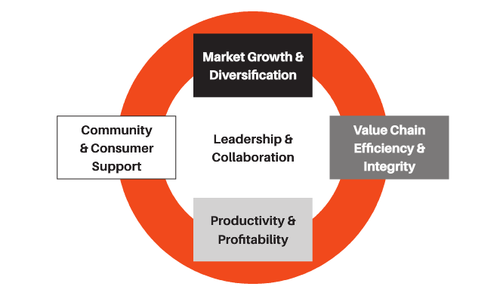

*Figure 1. BISP2020 Five investment pillar strategy*

It was identified in the BISP2020 that most of the priority areas do not simply fit under one pillar but are linked together for example animal health initiatives improve productivity, engender community and consumer support and impact on market access. The development of a holistic quality assurance and education program would capitalize on these links and hope to minimize documentation to achieve the greatest outcome. The program I have proposed in this report keeps in mind the 5 pillars of the BISP in the following way.

* **Consumer and Community Support** – Providing a mechanism to increase consumer support through improved standards and data collection allowing evidence based marketing of the industries performance in the fields of animal health and welfare, the environment and sustainability.
* **Market Growth and Diversification** - Providing a simplistic system which utilizes technology to allow evidence based marketing and streamlined access to certification or specific segments of the market
* **Supply Chain Efficiency and Integrity –** Improve QA integrity and compliance throughout the supply chain.
* **Productivity and Profitability** – Improve the ease and access to premiums offered products produced under a QA program. Increase
* **Leadership and Collaboration** - Create a more collaborative approach to providing information to producers.

1. **METHOD**

The method I used for this project was through undertaking case studies on selected existing QA programs. The aim of the case studies was to investigate what the key components of QA systems are and which have the greatest impact on the success of the program. The case study examples were selected based on sampling a broad variety of programs covering different aspects of the industry rather than systems auditing the same type of standards. This was done to ensure a broader range of methods used to implement a QA system was investigated. The key aspects were then identified as components that should be considered when designing a holistic industry program. I have then outlined how these components could be utilized in designing a program which covers On Farm Biosecurity, Animal Health and Welfare, Food Safety, Environmental Sustainability and Product/Meat Quality.

1. **CASE STUDIES**

**5.1 Livestock Production Assurance (LPA)**



*Figure 2. Livestock Production Assurance (LPA) logo*

Livestock Production Assurance (LPA) is Australia’s main livestock industry’s on-farm food safety program with more than 210,000 Property Identification Codes (PIC) currently LPA-accredited. Introduced in 2004, it provides an assurance of the safety of red meat grown on Australian farms and meets many export market requirements.

The industry driven program is an excellent example the whole red meat industry at a national level working together to meet consumer demands and export market requirements. It is voluntary program, however the majority of meat processors require livestock to be sourced from LPA-accredited properties. This has driven a most producers to become accredited. When producers sign up a property to LPA accreditation they commit to carrying out on-farm practices that support the integrity of the entire supply chain.

The program covers the following five areas:

1. **Property risk assessments**: To minimise the risk of livestock being exposed to sites that are unacceptably contaminated with persistent chemicals or physical contaminants.
2. **Safe and responsible animal treatments**: To ensure animal treatments are administered in a safe and responsible manner that minimises the risk of chemical residues and physical hazards.
3. **Stock foods, fodder crops, grain and pasture treatments**: To minimise exposure of livestock to foods containing unacceptable chemical contamination and guarantee livestock are not fed animal products.
4. **Preparation for dispatch of livestock**: To ensure livestock are fit for transport and minimise the risk of stress and contamination of livestock during assembly and transport.
5. **Livestock transactions and movements**: To ensure traceability requirements, with respect to treatments or exposure to food safety hazards, have been fulfilled for all livestock movements - between farms and feedlots, and including to slaughter and live export.

National Vendor Declaration (LPA NVD) is the main document used for a majority of livestock sales within Australia and declares LPA accreditation and allows traceability. The system is monitored through audits at random and also supplies and serial numbers from the LPA NVD’s are recorded on the NLIS database when cattle are sold or moved. Information and documentation templates are available online to assist producers and help ensure they meet the standards. The LPA website also provides online training so producers can improve their understanding of the requirements if needed. In recent months, it has been announced that as of the beginning of 2017 producers will be required to undertake an online test to ensure the requirements are understood every three years.

While the program is used to ensure market access it is not advertised directly to consumers in supermarkets in the way many other accredited products are. It may be something that needs further exploration.

**5.2 Pasture Fed Assurance Program (PCAS)**

PCAS is an industry driven pasture fed certification program designed and implemented by the Cattle Council of Australia. Its requires a annual on-farm audit which is payed for by the producers which covers specific requirements relating to the following 6 elements:

1. Identification and Lifetime Traceability
2. No Confinement for the Purpose of Intensive Feeding for Production
3. Lifetime Pasturefed
4. Minimum Eating Quality Standards (on-farm)
5. Lifetime free from Hormonal Growth Promotants (optional)
6. Lifetime free from Antibiotics (optional)

Meat processing companies can then use this in depended certification to underpin their brands or products. Teys Cargill are one of the companies which have taken up this program and the certification is used for the companies Grasslands brad, as shown in figure 3.

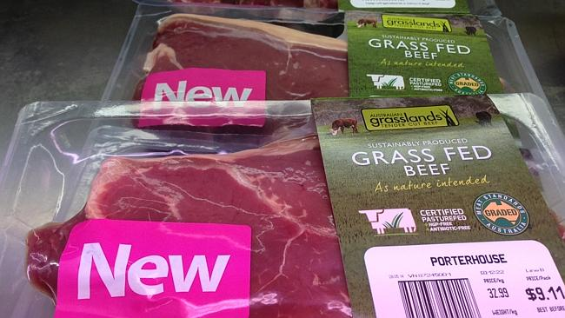

*Figure 3. Grasslands Branded beef using the PCAS certification label*

**5.3 Grazing Best Management Practice**

Grazing BMP is an Australian program that comprises of five modules; soil health, animal health and welfare, grazing and land management, animal production and people and business. The program is completely voluntary and designed to help producers make the most of their enterprise for its long-term sustainability. It allows producers to benchmark against industry best practice and identify opportunities and develop plans to improve a business’s performance. Another key to the success of this program in that it helps producers access information and support.

It is a program designed for producers in Queensland and so has specific focus on issues in that region. It is an excellent example of providing a framework to encourages improvement in a diverse range of aspects of a beef producing property. It also collects industry-wide data on practices whilst this is kept private it allows industry to monitor its return on investment in the program in terms of industry wide improvement. The program provides an opportunity to demonstrate that environmental stewardship and demonstrate that sustainability and ethics are important component that is being worked on by food producers. Whilst the program has been well taken up by beef producers the flow of information to consumers is not evident from my research however this may be occurring in a subtle way.

An important part of promoting the uptake of the program is its “Producers for Producers” moto as it is designed with a high level of producer input. This helps to create a positive image of the program to producers and ensures it is practical and relevant to businesses in the region.

This program highlights it is important to ensure a program is specific to regions and the standards reflect that to ensure it is effective.

**5.4 Origin Green- Ireland**

The Origin Green is an ‘sustainability charter’ for the food and beverage industry in Ireland. To date, over 43,500 Irish beef farms have been audited accounting for 90% of their total beef production. Having such a high level of participation provided the industry with not only assurance when marketing their product but a tool which can also be used in negotiating trade agreements.

The program utilises a ‘goal setting’ model and claims farmer ‘measuring, learning and improving, then measuring again’. Participants set targets and report progress (short, medium and long term goals). This model makes the program accessible to a much wider range of businesses and promoted change rather than just rewarding those meeting a high standard or target.

The program also claims to be “Making good on our promise that food and drink sourced from our farmers and food producers brings with it an independently verified proof of our commitment to sustainability.” The key aspects to the success of this program is that it is independently verified and creates a network used to communicate key issues. Being independently verified creates an excellent marketing tool for international consumer. The program also collects information showing industry is being proactive in the field of environmental sustainability. Figure ? shows an example of the style of marketing used by the program and the logo. The marketing tells a story of the people behind the brand and the ‘proven’ ‘commitment’ behind the products produced under the system.

[](http://www.google.com.au/url?sa=i&rct=j&q=&esrc=s&source=images&cd=&cad=rja&uact=8&ved=0ahUKEwjW6aHegJPQAhVLlJQKHTspC78QjRwIBw&url=http://smartagrifoodireland.com/&psig=AFQjCNFt0FMrJMA1YiaVRTXqgouXocFdkw&ust=1478483022763764)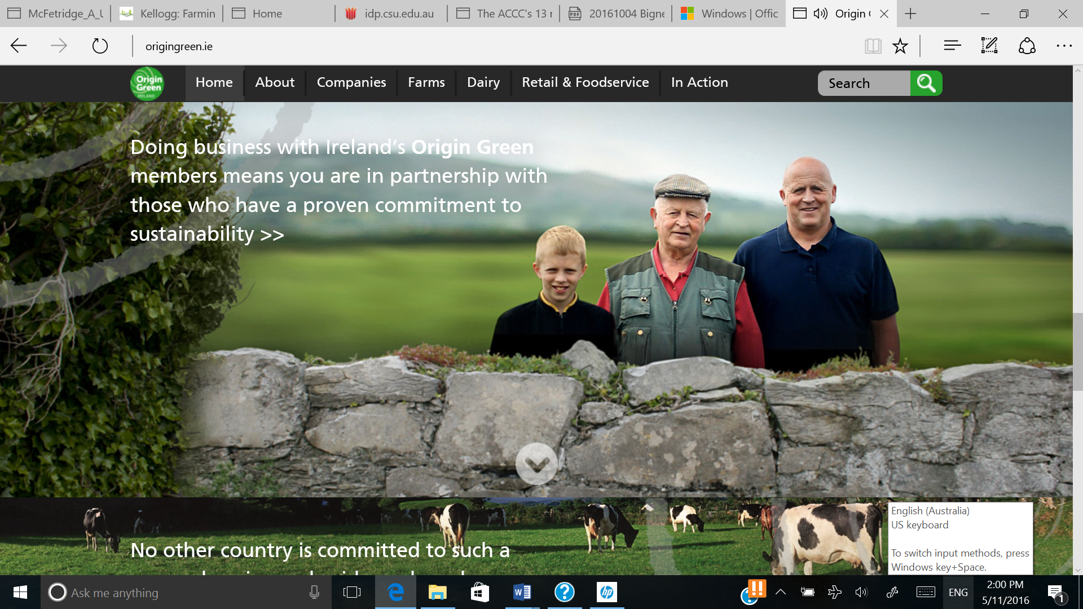

*Figure 4. Origin Green website and marketing material*

The Origin Green website provided information on market trends to participant and consumers. Highlighting the sustainability related market trends in other counties to potential participants provides a national ‘call to arms’ on the issue which would help drive participation and acceptance of the system. A selection of the simple way this is communicated by the program is shown in figure 5.

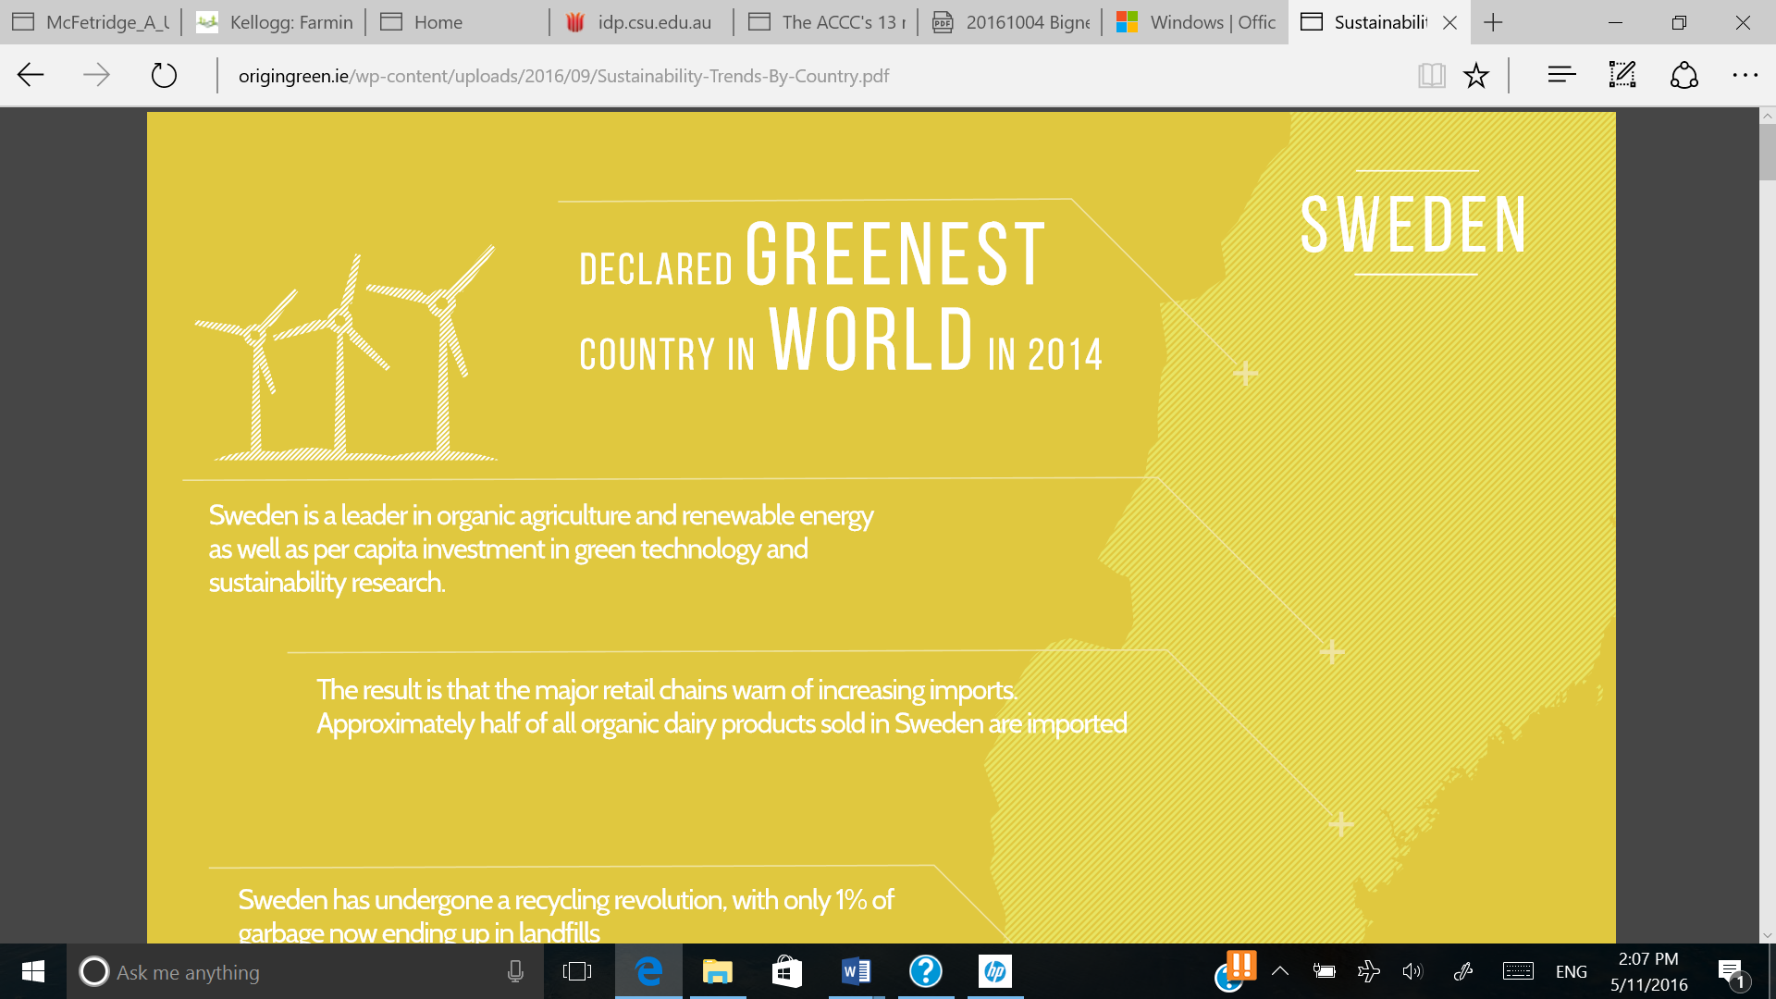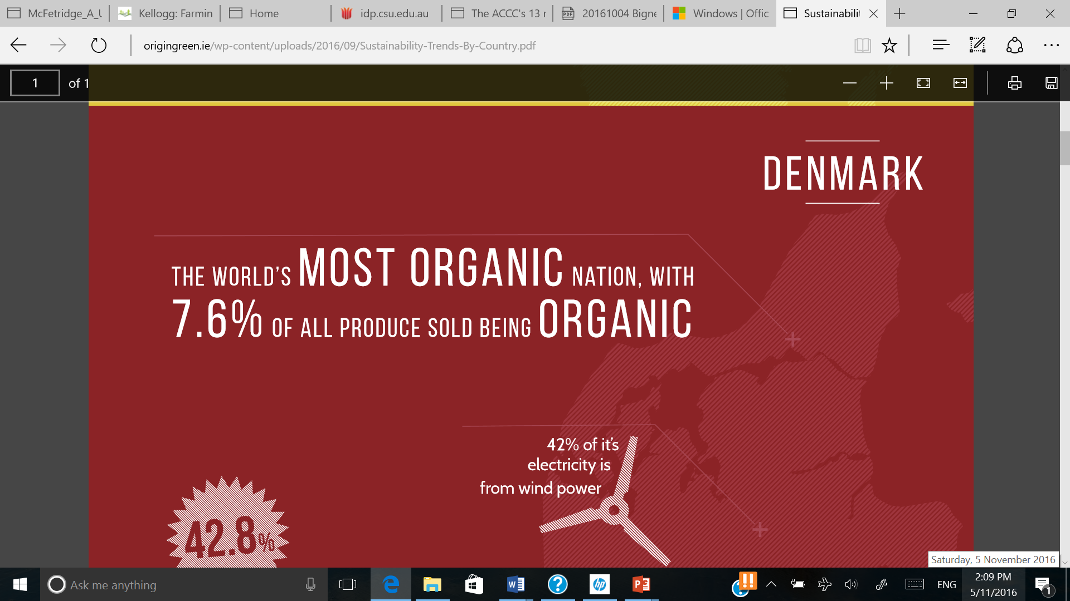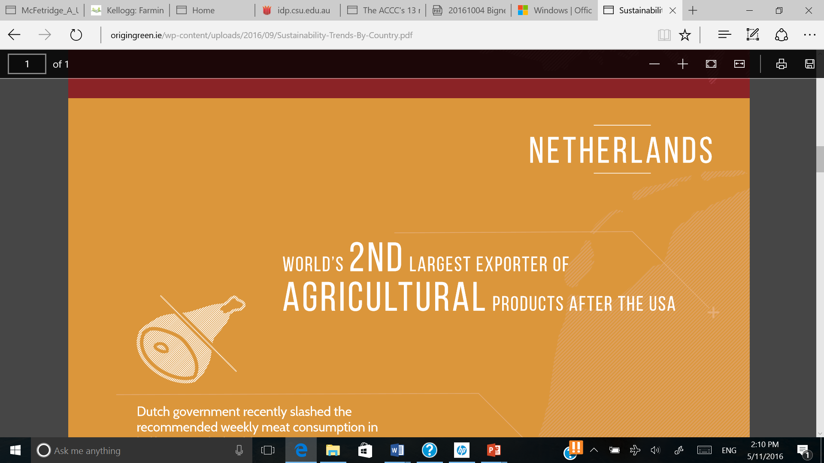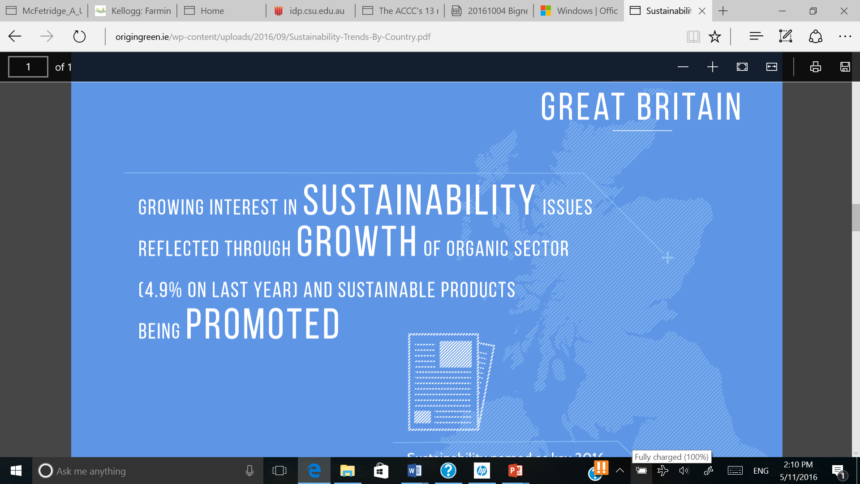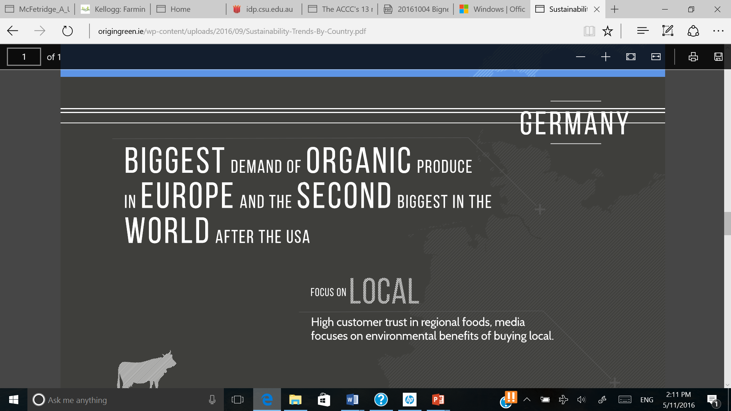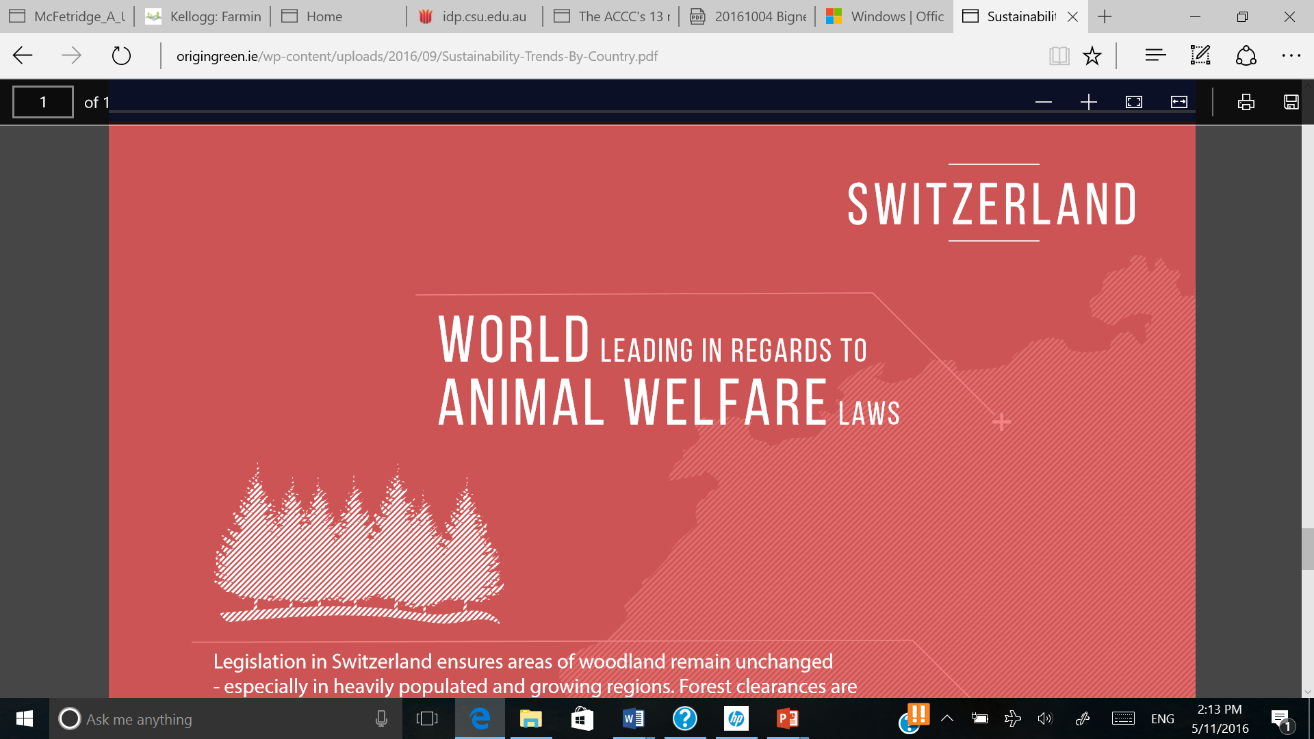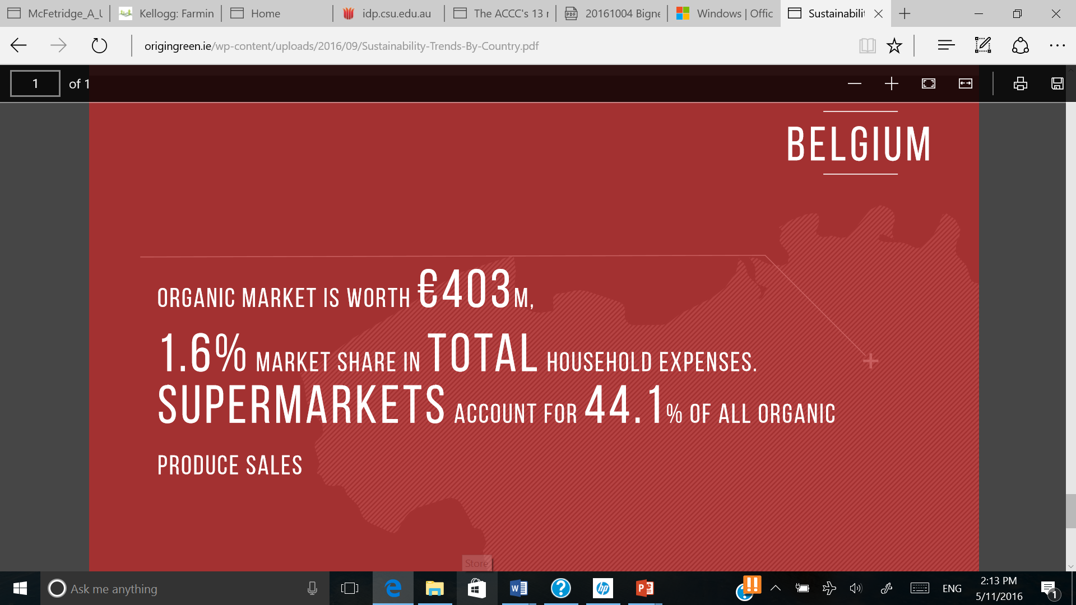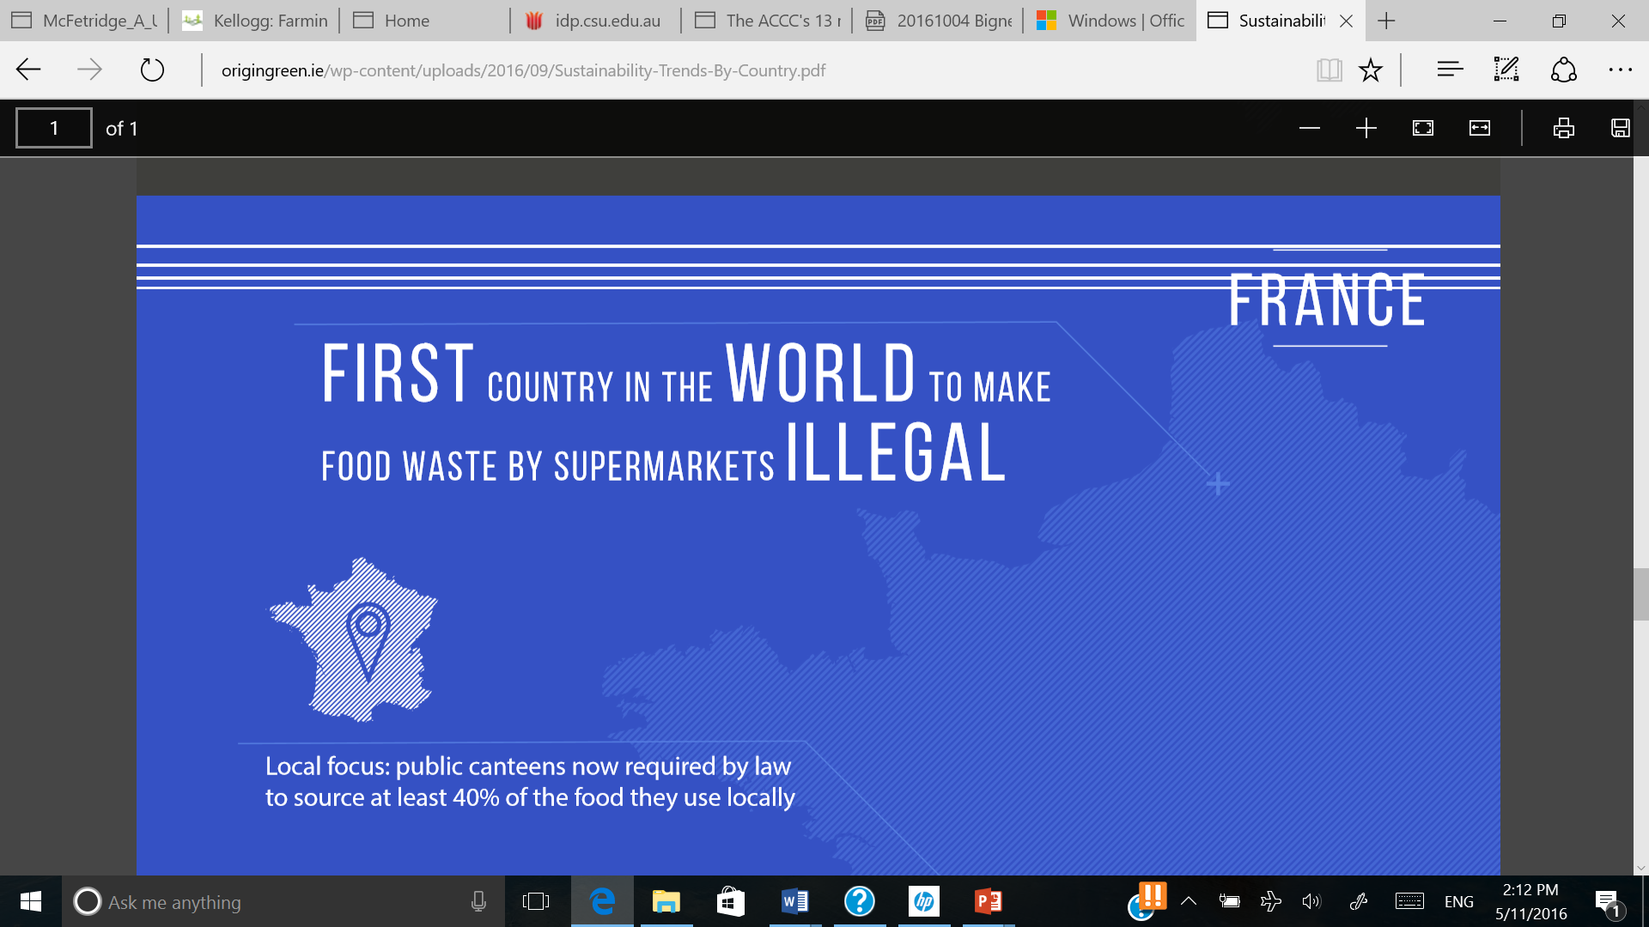

<http://www.origingreen.ie/wp-content/uploads/2016/09/Sustainability-Trends-By-Country.pdf>

*Figure 5. A selection of the marketing material highlighting the sustainability related market trends in other counties*

**5.6 RSPCA Approved Farms**

RSPCA Australia has certification programs aviable for Layer Hens, Meat Chickens, Turkeys, Pig and Farmed Atlantic Salmon. The programs aim to ensure caring and responsible planning and management of animals by skilled, well-trained, knowledgeable and conscientious staff. They also ensure appropriate environmental management and design, considerate handling and transportation and humane slaughter. RSPCA Approved Farming Scheme Standards regardless of the species are developed within a framework of the Five Freedoms:

1. Freedom from hunger and thirst — by providing ready access to fresh water and a diet to maintain full health and vigor
2. Freedom from discomfort — by providing an appropriate environment including shelter and a comfortable resting area
3. Freedom from pain, injury or disease — through prevention or rapid diagnosis and veterinary treatment
4. Freedom to express normal behaviour — by providing sufficient space, proper facilities and company of the animal’s own kind
5. Freedom from fear and distress — by ensuring conditions and treatment which avoid mental suffering.

RSPCA Australia agreement says they may undertake general marketing activities to promote the Scheme and Approved Products. Marketing is a done in a general way to encourage consumers to seek out Approved Products. Figure , shows examples of marketing used to promote the accredited products. As depicted in the advertisement Coles supermarket have underpinned all of ‘Coles brand’ chicken with RSPCA accreditation.

[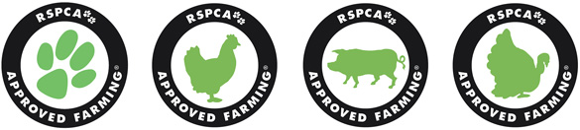](http://www.google.com.au/url?sa=i&rct=j&q=&esrc=s&source=images&cd=&cad=rja&uact=8&ved=0ahUKEwjxmMbpo5HQAhVIUZQKHVoDAZIQjRwIBw&url=http://kb.rspca.org.au/Where-can-I-buy-RSPCA-Approved-chicken-eggs-pork-and-turkey_96.html&psig=AFQjCNE1XVzWXUru4BGD371p8cCmetib9w&ust=1478423732570298)

[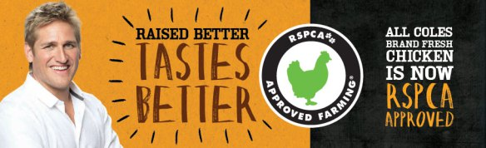](http://www.google.com.au/url?sa=i&rct=j&q=&esrc=s&source=images&cd=&ved=0ahUKEwjzkteYpJHQAhWCEpQKHR8oA5QQjRwIBw&url=http://brandstanding.com.au/2014/02/21/branding-for-profit-or-not/&psig=AFQjCNE1XVzWXUru4BGD371p8cCmetib9w&ust=1478423732570298)

*Figure 6. RSPCA approved certification promotional material*

1. **RECOMMENDATIONS**

As the beef industry programs evolve to meet changing consumer demands we should be steering towards a clear simple system that is based on market research and producer input. Market research will help to ensure the industry gets the most benefit from potential markets and producer input will help to build a system that is practical and accessible. The program should aim to reward behavior on-farm which builds a positive image for the industry.

The case studies showed that voluntary programs can work however they must be incentives to drive participation. PCAS demonstrates the industry’s ability to provide a tool which can be utilized by industry underpin products and build markets.

It is important that the program be national and available to all producers to have the greatest impact on market access. When looking to have the greatest impact on the industry a national program is most effective on creating movement in the pace of consumer perceptions. Origin Green is an excellent example of how effective a program can be if an industry can achieve a national approach. LPA demonstrates this is achievable in Australia however it lacks the strong marketing component of Origin Green.

It is imperative we meet consumers needs however it is also important to do this in a way that is accessible and realistic for beef producers. After investigating the existing programs in Australia and internationally it is clear there are many strength to the current programs. I believe this indicates it is best to maintain the current Australian programs and add programs/modules that further allow the industry to meet consumers demands and communicate the story behind beef production. The case studies highlighted to me that industry driven programs are successful and can provided consumer confidence so long as third part auditing is used to underpin.

As markets diversify and different QA programs are needed to underpin them and create consumer confidence it is important it is done in a way that is simplistic for both producers and consumers. Having an overarching online portal system would achieve this however industry collaboration and cooperation will be needed to allow this to occur. It should be explored further whether individual programs could still be run or owned by different origination but be accessed using one online interface.

Productivity and profitability is always the focus of any business and identifying areas which drive these components drives beef production. Australia has high production and processing costs compared to many of its competitors and therefore needs to meet expectation of high value markets to ensure profitability. It is important we look key areas which are key to the beef industry’s long term success. These components need to be address consumer’s needs, community support and risk management. My research identified the following components as being important to industry success and consumer and community support:

* Food Safety
* On Farm Biosecurity
* Animal Health and Welfare
* Environmental Sustainability
* Product/Meat Quality

These components are all underpinned by the effectiveness of the National Livestock Identification System (NLIS) (shown in figure 7) already running successfully in Australia. This system ensures all cattle have an electronic identification number which tracks its movement between properties and venues throughout its lifetime. Having this tool available allows the success of current QA programs and will underpin any future programs.

**Traceability**- *National Livestock Identification System (NLIS)*

Branding

Integrity

Industry Protection

Product Quality

*Figure 7. Diagram showing the relationships between the components of the proposed program*

Assessing the recommendations in the BISP and with consumer perceptions being heavily considered I believe the industry should provide additional programs that are separate to LPA food safety accreditation. Keeping these components separate would allow producers to take up the ‘modules’ or programs when it becomes necessary or a desire of their business.

*Figure 8. Diagram showing how the current programs may be able to fit under a new holistic model*

**6.1 ELEMENTS OF THE PROPOSED PROGRAM**

**On Farm Biosecurity**

On farm biosecurity is not only important to reduce the incidence of endemic disease but also to ensure producers take steps to prevent and report any possible exotic disease. Exotic disease awareness and prevention is important to ensure Australia maintains its high health status, which allows us to export both live animals and processed fresh meat.

The aim of this component would be to achieve the following outcomes:

* Reduce the risk of endemic disease transfers between animals, thus helping reduce negative impacts on animal welfare and/or reduce the need for chemical treatments.
* Reduce the risk of spread of pest and weeds between properties, which may have a negative impact on production, exotic disease spread, and the natural environment or wildlife.
* Improve exotic disease awareness, what to look for and who to contact in the incidence of a suspect case of an emergency disease outbreak.
* Improve producers awareness of potential exotic disease risks

**Animal Health & Welfare**

Animal welfare is an essential component for the industry going forward, creating a proactive approach of monitoring would help to both provide assurance to consumers the industry has a strong stance on maintaining compliance with animal welfare standards.

The aim of this component would be to achieve the following outcomes:

* Ensure the industry has incentives to encourage the continual reviewing and adoption of improved welfare strategies on farm. The program should ensure a direct flow of information to beef producers on the industries standards and guidelines as well as research outcomes that have the ability to improve welfare outcomes.
* Ensure producers have an understanding of the current welfare standards and guidelines; this could be achieved through a basic online questionnaire.
* Highlight to the producer the industries stance on welfare as well as increasing their knowledge of expectable standards. Welfare concerns reported to or through RSPCA, saleyards or other sources would trigger an industry audit or online questionnaire prior to the producer being able to sell cattle using the ‘LPA’ system.
* **Herd Health Plan** The herd health plan is a key component for seed stock and breeder herd to ensure their customers’ needs are met. It also is key to providing evidence producers are identifying and addressing biosecurity and welfare issues.

**Environmental Sustainability**

The aim of this component would be to achieve the following outcomes:

* Encourage the implementation of **pest plant and animal control**
* Monitor **water** management, both its use and the management of water quality.
* Encourage the protection of **biodiversity** and **vegetation management**.
* Awareness of **energy** use and **emissions**.
* Awareness of the industries contribution to its impact on the **Socio-Economic** contribution to the community

In some areas of Queensland beef producers are already involved with the Grazing Best Management Practice (GBMP). In the interest of creating a holistic program it would be beneficial if was taken directly into consideration and gave producers direct credit for the element.

**6.2 INSPIRING IMPROVEMENT ON- FARM**

Ideally each individual program would be a voluntary and provide a credit system for producers meeting standards, adopting research outcomes and being involved with education when relevant. The specific standards a producer wants to meet would be selected for themselves depending on how they want to tailor it to their businesses marketing needs or business goals.

The success of many of the accreditation programs in the case studies were through the programs design being based on levels and goal setting. This not only encourages improvement across the industry but also makes the programs accessible and not overwhelming for producers.

Adding a component to this model that gives credited for participation in educational programs could also help the industry to improve the issues surrounding low research outcome adoption rates. Significant investments in developing technological innovations have been made in the Australian beef industry but with low adoption rates *Daowei Sun, et al (2014)*. While there have been many break throughs in fields animal welfare and sustainability it is often difficult for producers to adopt them unless it achieves an increase in income or improved productivity.

*Daowei Sun, et al (2014)* suggests that innovation adoption is such an extremely complex issue, and we need to shift our views on this issue from a paradigm of linear thinking to systems thinking. With this in mind the development of a holistic QA program could also encourage adoption and continuous improvement. The program could be designed in a way create a holistic way for producers to access extension material and workshops relevant to their business’s needs.

**6.3 AUDITING**

The method, frequency and depth of any auditing system must be practical but also meet consumer expectations. Rather than a beef producer requiring many audits there could be one online portal which covers a range of industry programs.

For Example: A producer may want to meet basic standards for LPA and as specific program such as PCAS. They would be able to tick the boxes and add them to their profile. The documentation required and the audit could be summaries in one online porthole and then followed up on farm if required. They may also be interested in completing a more intensive suitability or animal welfare module because their customers have told them they will offer a premium in the future for this product. The producer may not be sure if they want to be accredited as yet however the website or application would allow them to completed the online requirements and identify if there are any areas needing improvement. The highlighted areas would then automatically recommend online recourse or dates on specific training available to rectify the issue if possible.



*Figure 9. Diagram showing a basic outline of how a farmer may be able to interact with the system online*

If such a system could exist Meat and Livestock Australia would also be able to collect data on areas producers need more information, training or research. This would help to ensure levy money is spent in an efficient way and addresses producer’s needs.

**Refences**

*Daowei Sun, Paul Hyland, Ockie Bosch (2014) A Systemic View of Innovation Adoption in the Australian Beef Industry, Systems Research and Behavioral Science, Volume 32, Issue 6 November/December 2015   
Pages 646–657*

*Duffy R., Fearne A., (2009) Value perceptions of on farm assurance in the red meat supply chain, British Food Journal Volume 111 No. 7 Pages 669-685*

*Edge M. K., Barnett J. L., (2008) Development and integration of animal welfare standards into company quality assurance programs in the Australian livestock (meat) processing industry, Australian Journal of Experimental Agriculture, Volume 48 pages 1009-1013*

[*Kilpatrick*](http://www.tandfonline.com/author/Kilpatrick%2C+Sue) *S.,* [*Morgan*](http://www.tandfonline.com/author/Morgan%2C+Helen) *H., &* [*Falk I., (1999),*](http://www.tandfonline.com/author/Falk%2C+Ian)*Quality Assurance in the Beef Industry: The dilemma of visions and values, Rural Society Volume 9 Pages 353-366*

*Websites*

*Beef Central (2016) http://www.beefcentral.com/markets/record-prices-for-organic-cattle-defies-broader-market-trend/*

*Beef Central (2015) http://www.beefcentral.com/features/beef-2015-report/beef-2015-briefs-pcas-delivers-4-million-in-* *http://www.origingreen.ie/premiums/*

*Beef Central (2013)* http://www.beefcentral.com/trade/jbs-unveils-new-qa-*driven-southern-grassfed-brand-program/*

[*http://www.pcaspasturefed.com.au/*](http://www.pcaspasturefed.com.au/)

[*http://www.origingreen.ie/*](http://www.origingreen.ie/)

[*https://lpa.ausmeat.com.au/Account/Login?ReturnUrl=%2F*](https://lpa.ausmeat.com.au/Account/Login?ReturnUrl=%2F)

[*https://www.rspca.org.au/what-we-do/rspca-approved-farming-scheme/how-join*](https://www.rspca.org.au/what-we-do/rspca-approved-farming-scheme/how-join)

*https://www.bmpgrazing.com.au/#&panel1-1*