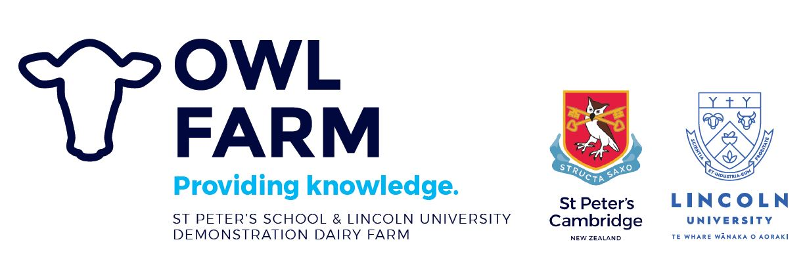

OWL FARM ASSOCIATE MEMBER PROGRAMME

Application form

Please complete all sections of this form and return by Friday, 30 April 2021 in confidence, with a copy of your CV and any additional pages to support your application. Email: jo.sheridan@owlfarm.nz Contact Person: Jo Sheridan, phone 021 712 680

First Names: |  | Last Name: |  | Date of Birth:
Address:

Postal Address (if different)

Landline: | Mobile: |  | Email:

Checklist
Before you send your application form, please ensure you that you have:

- Read the Application Criteria at the end of this document
- Completed all sections of the application form
- Attached your Curriculum Vitae
- Attached any additional pages you wish to support your application
- Signed and dated your application.

YOU AND GOVERNANCE
1. What do you hope to achieve from participating in the Owl Farm Associate Member programme?

2. What qualities and skills do you have that make you an effective leader?

3. List any governance positions you currently hold or have held, e.g. Trustee of school Board or involved in local community Boards.

GOVERNANCE IN ACTION

4. What are the objectives / what are you trying to achieve with your business?

5. What measurements do you use to ensure your business is performing effectively?

6. What do you think will be the issues facing New Zealand farmers in the future?

Declaration
I understand that if my application is successful and it is subsequently discovered that information I have provided is not complete or accurate, or I have failed to disclose relevant information, my inclusion in the programme may be terminated.
Full name:
Signed: Date:

Privacy Act 1993
The collection, use, storage and disclosure by Owl Farm of any personal information about you is subject to the Privacy Act 1993. The personal information will be held at the business premises of the Owl Farm. You may access and correct your personal information by contacting the Owl Farm.
The personal information will be used by Owl Farm to select those individuals eligible to participate in the Owl Farm Associate role.
You irrevocably authorise:
(a) Owl Farm, for the above purpose, to use, disclose to any third party, and to seek disclosure of your personal information from any third party;
(b) Any third party to release to Owl Farm upon request personal information about you for the above purpose; and Owl Farm to make enquiries about you as considered necessary for the purpose for which personal information about you is collected from any third party deemed appropriate by Owl Farm.

Owl Farm Management Committee – Associate Member

Purpose
To grow young farming leaders in the farming community through associate membership on the Owl Farm Management Committee, by learning the principles of management and governance in a supportive environment.

Objective

Identify future farming leaders and offer a unique governance development opportunity for the Associate Member, whilst also helping Owl Farm further its goals.

Description
The role of Farm Management Committee Associate Member will be:
- Held by up to two individuals at any one time on the committee;
- For a term of 18 months, likely beginning 1 June;
- To attend all 11 FMC meetings and 4 Owl Farm Focus Days during their tenure;
- Able to participate in all committee discussions and voting planning, but hold no voting rights;
- Required to hold discussions of the FMC in confidentiality
- Remunerated with a meeting fee of $100/meeting;
- Reporting to the Farm Management Committee Chair;
- Farming in Waikato or Bay of Plenty;
- Showing interest and leadership potential already.

Person Specifics
The Associate Member should demonstrate:
- Appropriate behaviour of someone in a leadership position for New Zealand dairy farmers.
- Sound farming practices that align with the policies and standards of Owl Farm in Health and Safety, Animal Welfare, Environmental Excellence and People Management.
- Philosophical alignment with Owl Farm’s farming objectives (seeking a sustainable business in the areas of Finance, Animals, Environment, People & Community). Not to be confused with “same farming system” as Owl Farm. The associate must share the belief that all four areas are important and respected.
- Commitment to the New Zealand dairy industry and desire to take learnings into the community.
- Time availability to attend all committee meetings, Owl Farm Focus Days and Open Day.
- Preparedness to participate as required in presenting at Owl Farm events where appropriate opportunities arise.
- Ability to be forthcoming on the issues – no matter how tough – to ensure we reach the right outcome.
- Prepared to examine their own farm business with a wagon wheel approach.

Criteria
Ideally, applicants should be in the early stages of their leadership journey. Where possible the opportunity will be presented to someone who presently holds limited (or no) other governance roles.

